**Point Absorber and Supplementary Charging Circuit Manual Guide**

**Scientific Shark**

**WATER**: Wave powered Autonomous Tethered Examining Robot

In 1989, an Exxon oil tanker hit a reef, spilling more than 11 million gallons of oil into Prince William Sound, devastating the ecosystem. A moored profiler was placed in the sound to monitor the health of the ecosystem. Currently, the scientists must go out weekly to charge the profiler and download data. Our project is to design a prototype of a new profiler that includes an innovative way to charge the profiler and communicate the system over longer distances.

**Point Absorber Guide**

**Materials**

* 1x 2” PVC pipe
* 2x 2” PVC end caps
* 3x 25mL ClearWeld Quick-Set Epoxy Syringe
* 1x 16 oz. Gaps and Cracks Insulating Foam Sealant with Quick Stop Straw
* 1x Temflex 3/4 in. x 60 ft. 1700 Electrical Tape Black
* 48x Rare Earth 3/4 in. x 1/4 in. Disc Magnet

**Installation**

1. **Magnet Holder Setup**

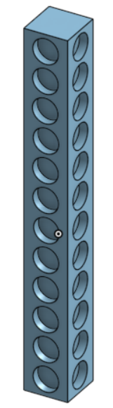

South-Side

South-Side

North-Side

North-Side

**Figure 1.** Magnet holder

Using epoxy to hold the magnets in place, magnets are to be placed in the order of north-side, south-side, north-side, south-side, and so forth until the column is completed. Each column should have the same order as the previous column; therefore, each row is the same magnetic pole and alternate as each one passes.

1. **Magnetic Copper Coil Setup**

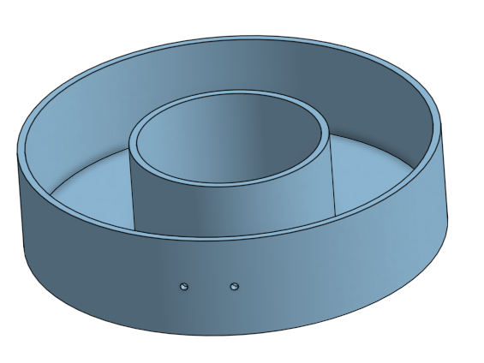

**Figure 2.** Magnetic copper coil doughnut holder

For the outside magnetic copper coil doughnut holder, magnetic copper coil should be wrapped within this device. The more magnetic copper coil will result in higher voltage output. To put into perspective, for this capstone project, over 7, 200 wrappings were made within this device. When completed, cut the magnetic copper wire and have 2 wires poking out of the two small holes in the front (one for positive connection and the other for negative).

1. **Assembly**

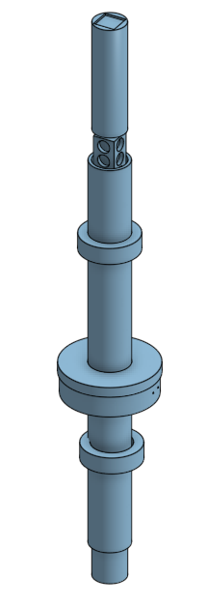

End stoppers (see final documentation and CAD files)

Magnet holder placement (see CAD files)

**Figure 3.** Overall system

Once Step I and II are completed, assemble all parts within a 2” PVC pipe and seal all visible cracks with sealant. Testing may be done using via an oscilloscope using the 2 wire connections made in Step II.

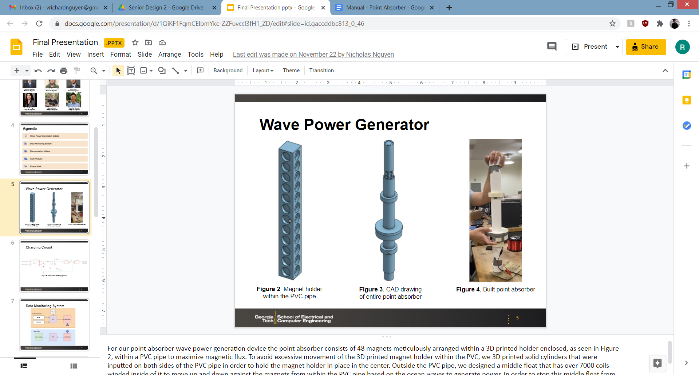

**Figure 4.** Prototype used for testing

**Charging Circuit**

**Materials**

* 1x Piezoelectric Energy Harvester
* 2x Super Capacitors
* 1x nMOS transistor
* 2x Schottky diode
* 2x 10K ohm resistor
* 1x 100K ohm resistor
* 1x DC/DC Boost converter
* 1x Adafruit Mini Lipo w/Mini-B USB Jack - USB LiIon/LiPoly charger

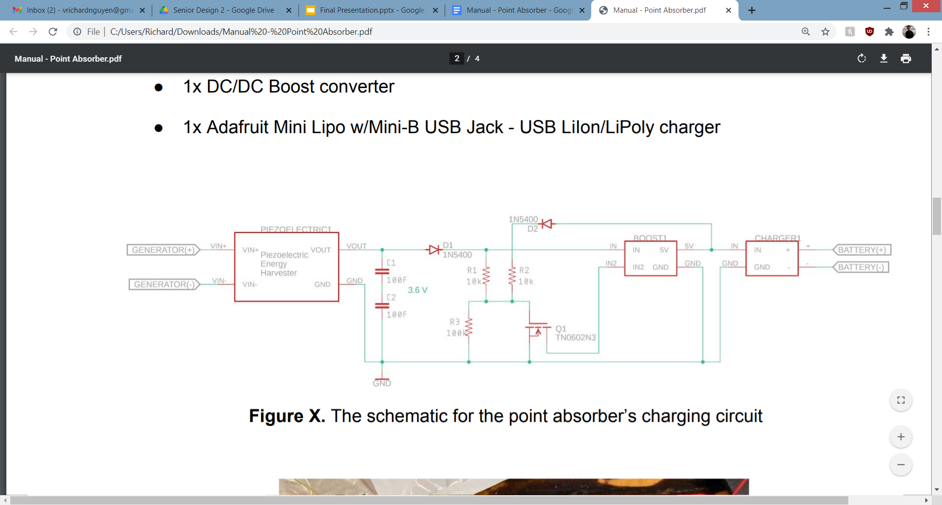

**Figure 5.** The schematic for the point absorber’s charging circuit

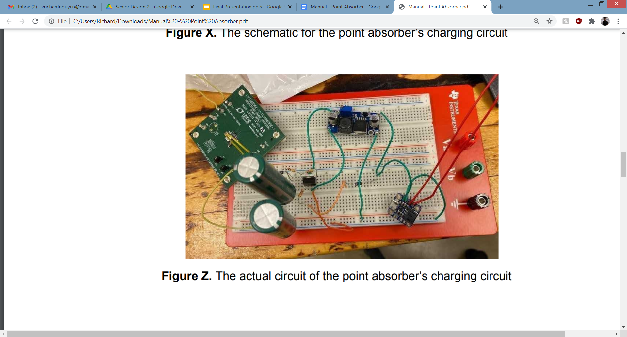

**Figure 6.** The actual circuit of the point absorber’s charging circuit

How it works:

The piezoelectric energy harvester is connected to two super capacitors connected in series, which will store the power being supplied from the point absorber until they hit a certain threshold. Once that happens, the switch will close allowing for the super capacitors to discharge. This will then send power to the boost converter, then to the battery power management board, which will light up verifying that the battery is being charged, and allow safe charging.

Voltages:

* Output form energy harvester: 3.6V
* Stored in Super Caps: 3.6V
* Maximum stored in Super caps: 5.4V
* Threshold of nMOS: 2.5V
* Input to boost converter: 3.6V
* Output form boost converter: 5V
* Charging chip input requirement: 5V

**Testing**

On the power generation side, we demonstrated and validated this project by using laboratory instruments and putting together the manufactured point absorber and charging circuit. The following were done to test these devices:

* An independent DC power supply was hooked onto our charging circuit with a constant charge of roughly 6V to showcase the charging circuit was functioning properly, which would be indicated by a LED being lit up on the battery power management board.
* An oscilloscope was hooked into our point absorber generator to showcase and validate power being generated from the point absorber by moving the outer copper doughnut up and down the PVC pipe along the magnets from within.Our point absorber generator was able to generate roughly a minimum of about 3.5V at a steady motion and a maximum of 10V.
* With confirmation of power being generated, the point absorber was soldered onto the piezoelectric energy harvester, which is connected to the rest of the charging circuit, and used to generate power to the charging circuit until the battery power management board lit up - indicating that a safe charging sequence has indeed begun to the battery.

**Future Work**

The design implemented in this project could have further improvements to be made on it since we were only able to charge a single 3.7V battery cell. For example, due to the scale of our project, it will not be enough to charge a 30V battery as targeted; however, our design could produce that type of voltage in the future by supplying more magnets into the magnet holder design and wrapping more coil within the outside copper doughnut design. By adding more magnets into the holder, the design will increase in size; therefore, giving more surface area for the copper to interact with. In addition, with the addition of more wrapped magnetic copper wires, the power generated from this device would substantially increase as a result.  A future group could also test the prototype in a more realistic environment, first in a wave tank, then in the ocean.

**Software Guide**

GitHub Repo: <https://github.com/csmith608/ScientificShark>

**Code Organization**

We have code for three separate systems in this repository:

* profiler: contains code running on the Raspberry Pi that is the processing unit for the moored profiler, including running the sending radio, collecting data, and running the winch
* base_station: contains the code running on the base station Raspberry Pi, including the receiving radio and user interface
* diyBMSv4Code @ cd5c401: a submodule containing the diyBMS code created by Stuart Pittaway and modified slightly to send the battery information through the debug pins

# Installation

First clone the whole repository:

git clone <https://github.com/csmith608/ScientificShark.git>

Switch into the ScientificShark directory and initialize the submodule:

git submodule init

git submodule update

The WEMOS on the diyBMS controller board needs to be flashed with the code in the diyBMSv4Code @ cd5c401 -> ESPController as instructed in this video: <https://www.youtube.com/watch?v=wTqDMg_Ql98>

Each ATTiny on each diyBMS cell module board also needs to be flash with the code in diyBMSv4Code @ cd5c401 -> ATTINYCellModule as instructed at the end of the above video (<https://www.youtube.com/watch?v=wTqDMg_Ql98>)

The Raspberry Pi acting as the profiler will need to be connected as shown in the Pinouts section and the Python file in the profiler directory is run

The Raspberry Pi acting as the base station only has the LoRa Radio bonnet attached and the two Python files in the base_station directory are run

# Libraries

The following python libraries are required:

* PySerial -- pip3 install pyserial
* matplotlib -- pip3 install matplotlib
* RPi.GPIO -- pip3 install RPi.GPIO

To run the python files that include radio sending/receiving the Adafruit CircuitPython libraries must be installed, the directions and wiring are included here <https://learn.adafruit.com/adafruit-radio-bonnets/rfm9x-raspberry-pi-setup>

For working with the diyBMS code, created by Stuart Pittaway, please see the source repository <https://github.com/stuartpittaway/diyBMSv4>

Adam Welch has informative videos for working with the diyBMS components: <https://www.youtube.com/watch?v=bFUMxgrz-yo>

# Pinouts

[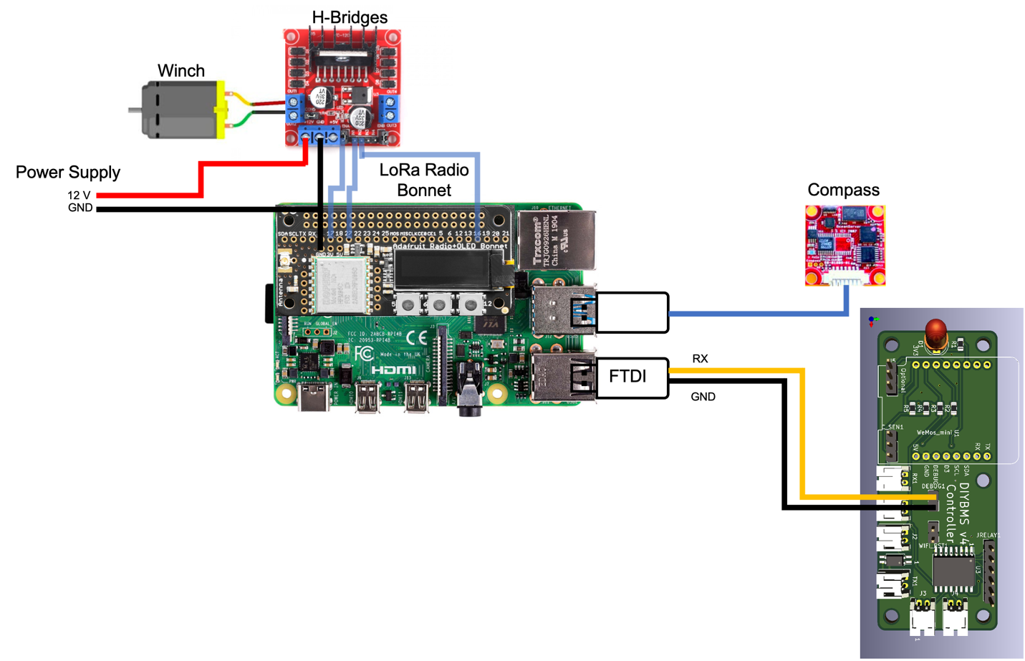](https://github.com/csmith608/ScientificShark/blob/main/images/Profiler%20pinout.png)

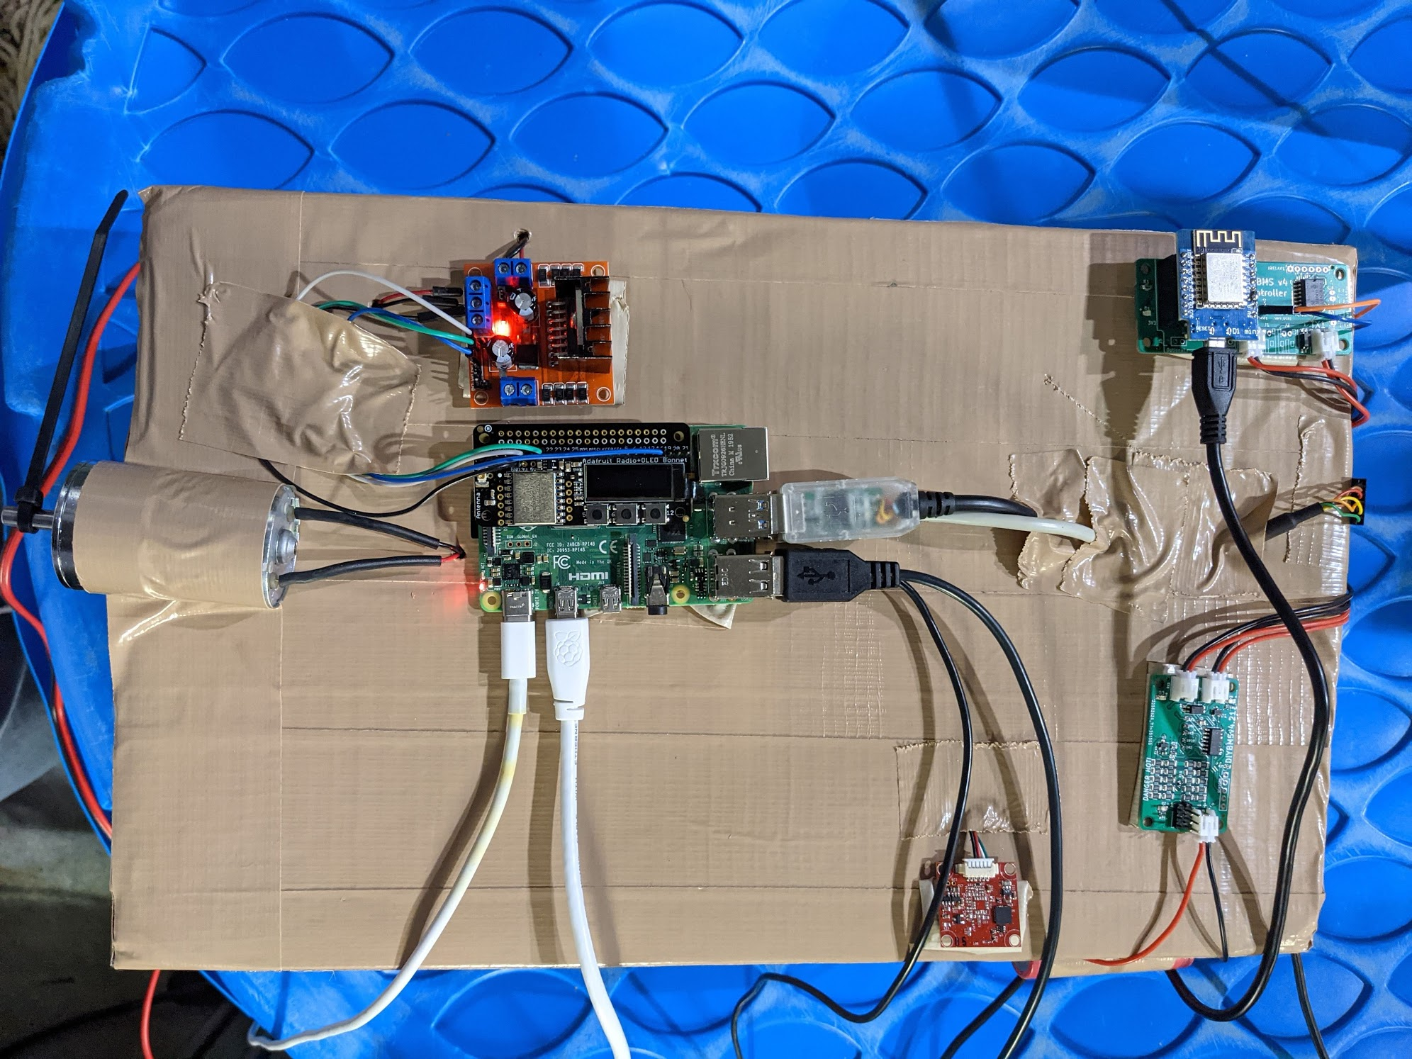

# Future Work

Some future work for the data monitoring system include:

* Adding additional error checking
* Integrating in actual sensors
* Making a physical structure for the system
* Upgrading the radios, either by switching them out or adding antennas
* Upgrading the processor
* Switching out the WEMOS, either by replacing it or receiving information from the ATTiny’s directly on the central processor
* Adding additional functionality to the user interface