WATER: Wave powered Autonomous Tethered Examining Robot

ECE4873 D1A Senior Design Project

Team Name: Scientific Shark

Project Advisor: Dr. Michael E. West

Rahil Ajani, EE, rajani3, rahilajani@gatech.edu

Srushty Changela, CmpE, schangela3, srushty@gatech.edu

Kombundit Chitranuwatkul, EE, kombundit3, kombundit3@gatech.edu

Nicholas Nguyen, CmpE, nnguyen99, nnguyen99@gatech.edu

Richard Nguyen, EE, rnguyen36, richardvnguyen@gatech.edu

Celeste Smith, CmpE, csmith608, celestesmith@gatech.edu

Submitted

2020 December 8th

**Executive Summary**.

In 1989 an Exxon oil tanker ran aground, spilling more than 11 million gallons of oil into the Prince William Sound [1]. After cleanup efforts damaged the ecosystem even further, Exxon began funding research efforts in the sound that allow for monitoring of the ecosystem and restoration efforts. The scientists currently use a moored profiler that was made by Sea-Bird Scientific which they have added instruments such as a plankton camera. Unfortunately, there are some problems with the current system and Sea-Bird Scientific has discontinued production and support for this profiler. The scientists came to Dr. West over the summer and proposed the idea of designing a new profiler. The new system would overcome the biggest disadvantages of the current system and leave them with a system that they could extend to provide even more functionality in the years to come.

After speaking with the scientist we concluded that the biggest problems with the current design, and most important features in the new design were: a way to remotely charge the battery, they currently have to go out on a boat and pull the profiler out to charge it once a month; a way to remotely receive information, they can only receive very simple telemetry, but would like to get scientific data.

Our group built a prototype of a new moored profiler that will have a wave power generator that will charge a battery. It will have a long-range radio for scientific data transmission. We will also have a digital compass as an example sensor and a winch for deployment. Finally, we will use a Raspberry Pi as the processor and include interfaces that can support the current instruments. The cost will be 311.89 dollars.

A future group will work to integrate the required instrumentation. They will also upgrade components to suit the environmental and power requirements of the actual system.

**Nomenclature:**

BMS = Battery Management System

GUI = Graphical User Interface

LoRa = Long Range, a low power long range communications device

PWS = Prince William Sound

RPi = Raspberry Pi

**1. Introduction**5

Objective 5

Motivation 5

Background 6

**2. Project Description and Goals**7

**3. Technical Specifications & Verification**9

**4. Design Approach and Details**10

4.1 Design Approach 10

4.2 Codes and Standards 19

4.3 Constraints, Alternatives, and Tradeoffs 19

**5. Schedule, Tasks, and Milestones**25

**6. Final Project Demonstration**26

**7. Marketing and Cost Analysis**28

7.1 Marketing Analysis 28

7.2 Cost Analysis 29

**8. Conclusion**30

**9. Leadership Roles**32

**10. References**34

**Appendices**37

**WATER: Wave powered Autonomous Tethered Examining Robot**

# 1. Introduction

In 1989, an Exxon oil tanker hit a reef, spilling more than 11 million gallons of oil into Prince William Sound, devastating the ecosystem. A moored profiler was placed in the sound to monitor the health of the ecosystem. The current profiler has a number of problems which the team is proposing to solve by creating a new moored profiler, the prototype created this semester cost $311.89.

## Objective

The current system has a number of problems so scientists at Prince William Sound turned to us to begin designing a new system. The biggest problems with the current system is that there is no remote charging capability, scientists must go out and charge the profiler every month, another problem is that there is limited data transmission, much of the data is collected when the scientists are charging the system, and the profiler is proprietary and is no longer supported by the manufacturer.

To overcome these challenges in the new system we will implement a point absorber power generator to continuously charge the battery, we will include a radio module to remotely send data collected from the instruments and battery cells that will be received by a base station Raspberry Pi and shown on a user interface.

## Motivation

We chose this project because the group saw it as a way to utilize both the computer and electrical engineering skills that were prevalent. This project is new in this type of situation; however, several industry projects have been made in the real-world that were used as inspiration for this project. With that being said, the Prince William Sound scientists would use this product to assist in further research. Our project improves upon existing products by utilizing the fundamental research drawn from these designs and small scaling it to meet this project’s demands. As a result, our project is more cost effective than existing products because existing products are made to larger scales that potentially cost thousands of dollars whereas the prototype this semester is roughly $311.

## Background

There are several industry-based projects that could relate to the scope of this project. Outside the proposed point absorber wave generator that was manufactured, we researched and based initial designs on wave attenuators and submerged pressure differential.

Pelamis Wave Power was able to design and manufacture a large scaled wave attenuator called the Pelamis Wave Energy Converter, which was the world’s first commercial scale machine to generate electricity to the grid from offshore wave energy and the first to be used commercially [22].

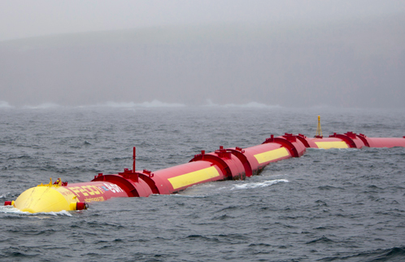

**Figure 1.** Example of attenuator [22]

In addition to the wave attenuator, we looked at submerged pressure differential designs as well. A lot of designs and information regarding this type of wave generation were theoretical; therefore, we looked into the National Renewable Energy Laboratory database and discovered a paper titled “Submerged Pressure Differential Plate Wave Energy Converter with Variable Geometry.” This paper included theoretical research regarding this design and suggestions of how it could be implemented in the real word [23].

For a data monitoring system, we used commercially available parts that have been used for many different applications. For example, the RPi and LoRa radios have been used in applications from environmental monitoring to healthcare [16].

# 2. Project Description and Goals

Our team will be redesigning an existing moored profiler to overcome its greatest challenges. A PWS profiler will be prototyped, which consists of:

* A 30V battery that will be built by Dr. West
  + For the prototype a single 3.7 V battery cell was used
* A communication system demonstrating higher bandwidth and precise data
  + The radio used does not implement higher bandwidth, but could be modified to achieve this
* A point absorber wave generator to trickle charge the battery
* A winch
  + 3D printed parts will be added by future groups
* A raspberry Pi 4 processor with interfaces for all sensors
* An example sensor, a digital compass
* A base station running a user interface on a Raspberry Pi

An initial prototype will be created which does not meet the exact requirements of the customer, such as a high enough transmission range and high enough power generation, but the current prototype could be improved to meet those requirements.

To allow for self-charging, we will be using the point absorber method to derive the wave energy and is powerful enough to generate power for the current instruments such as the Seabird FASTCAT, RBR brevio, Seabird Eco FLNTU, Seabird SBE 63, Aanderaa Optode, Seabird SUNA, and plankton camera. The power generation required for the new system will incorporate point absorbers, which are wave energy converters that are made up from two primary parts: a spar that is moored to the seabed and floater/buoy that will move vertically according to waves. In a real implementation, the power generated from the converter will be connected via subsea cable and transferred to the profiler allowing trickle charging, in our prototype it will just be connected via a cable. The alternatives for attenuators are other renewable sources such as solar and wind energy, and wave power converters like submerged pressure differential and point absorber. More detailed information about power/energy for the PWS autonomous moored profiler such as technical specifications, design ideation, constraints, and design alternatives are mentioned in the following sections of this proposal.

The data monitoring system will be equipped with a Raspberry Pi 4 processor to allow remote accurate data collection. The RPi processor will be able to communicate with the winch, compass, battery management system, and communications module through their respective communication interfaces. An Adafruit LoRa Radio Bonnet module will be the communications module, providing long range communication, alternatives were not considered, due to the scope of the project. We picked the Raspberry Pi processor as we have worked with this platform before so rapid development will be possible. Each component will be discussed in more detail in the following sections.

There are quite a few challenges involved in this procedure such as the intricacy of the marine ecosystem, unavailability of renewable energy sources, insufficient communication systems, and interfacing solutions. Also, the RPi4 processor has a tradeoff as it consumes a comparatively high power of 540mA (2.7W) at idle and 1280 mA (6.4W) at 400% CPU load [7]. Furthermore, using wave energy can be expensive and difficult to use because of its current location in the Gulf of Alaska, but it is still preferred compared to others such as solar or wind energy sources. A future implementation could combine wind, solar, and wave energy.

Based on the customer’s requirements, it is necessary to replace the current energy source that requires charging every month, with the wave power generator, and have a system that allows precise and remote data collection. There are aspects of the project that we do not implement, such as full integration of current sensor capability, high enough communication bandwidth, and great enough power generation. But we believe that executing the following changes in the profiler will save time and energy of scientists, as they won't have to travel up to the Prince William location in the Gulf of Alaska to charge and collect data from the profiler every month. Due to the nature of this project, the customer does not have a target price for the final product, but the prototype budget is $700.

# 3. Technical Specifications & Verification

**Table 1.** Target technical specifications of the system

|  |  |  |
| --- | --- | --- |
| Specification | Updated Value | Measured Value |
| Target Voltage Generation | 5 V | 3.2 - 10 V |
| Target Communications Range | >1.5 km | 2 km |
| Communications Frequency | ~915 MHz | 915 MHz |
| Voltage to Battery | 3.7 - 4.2V | 4.2V |
| Current to Battery | 100 - 500mA | 500mA |

The proposed technical specifications as well as the measured specification from the prototype are shown in the table above. The voltage generation specification refers to the voltage being produced by the proposed generator. With the proposed generator, the team theoretically would want to produce a minimum of 3.2V to the battery to charge. On the low end of power supply, we would just be supplying the RPi doing processing and the LoRa radio, on the high end is powering all sensors. Next, the communications range is the range that the profiler should be able to transmit data. The communications frequency specification is determined by the operation frequency of the LoRa radio bonnet which can range between 860 MHz and 915 MHz and is configurable in the software. The voltage and current to the battery will be measured from the output of the charging circuit.

# 4. Design Approach and Details

## 4.1 Design Approach

From initial meetings with the leads of the project, we understood that our design must be functional while submerged, produce enough energy from ocean waves, and charge a battery cell sufficiently. As a result, for this project, we decided to implement the point absorber wave generator design. Point absorbers are floating structures that have a small horizontal dimension compared to their vertical dimension and utilize the wave action at a single point. Most designs for point absorbers resemble a typical buoy, at least from the surface. Generally, one end of the absorber is fixed (or relatively fixed compared to the water surface) while the other moves in a vertical motion, the resulting reciprocating action is used to pump a fluid or drive a linear generator, which in turn can provide usable power. Point absorbers are one of the most common design types in the industry today [6].

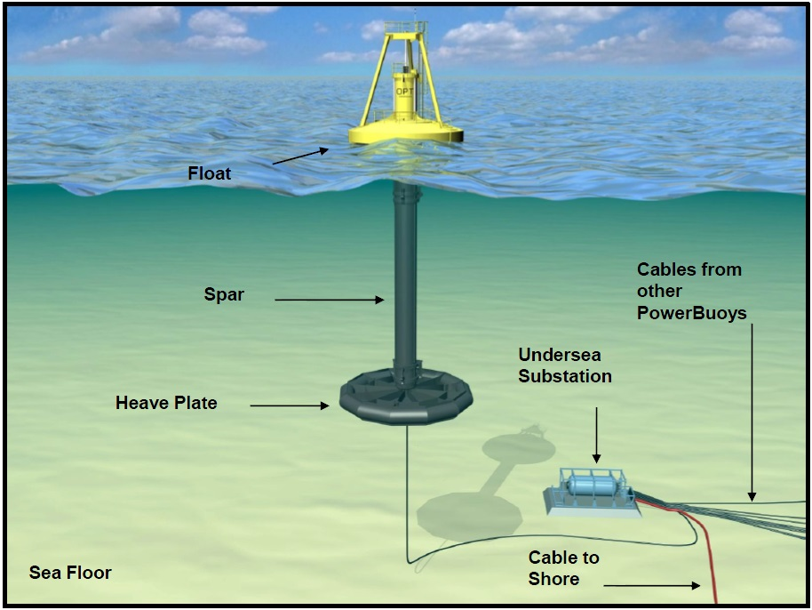

**Figure 2.** Example of the point absorber

For this implementation, we decided to design a simple point absorber design, as seen in the figure below, that would utilize the following parts: a PVC pipe, 48 super magnets, 3D printed stoppers and magnet holder, and magnetic coil wire. A custom 3D printed magnet holder was designed and manufactured to meticulously place the magnets in an order to produce magnetic waves and interact with the magnetic copper wire that would be pushed along the PVC pipe and magnet holder. The placement of the magnets, starting from the top to bottom, north-side, south-side, north-side, and so on until the end. Each side will have the same configuration. Also, to prevent overshoot of the copper wires along the PVC pipe, we manufactured end stoppers on opposite sides of the PVC pipe.

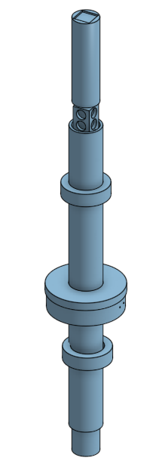

**Figure 3.** Point absorber design

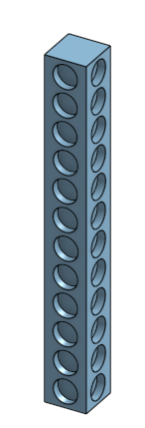

**Figure 4.** Custom designed magnet holder to be put inside PVC pipe

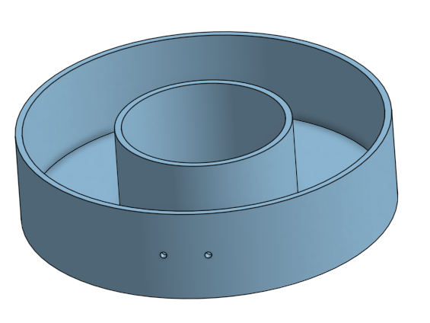

**Figure 5.** “Doughnut” to put outside PVC filled with magnetic copper wire wrapped inside to interact with super magnets inside PVC pipe

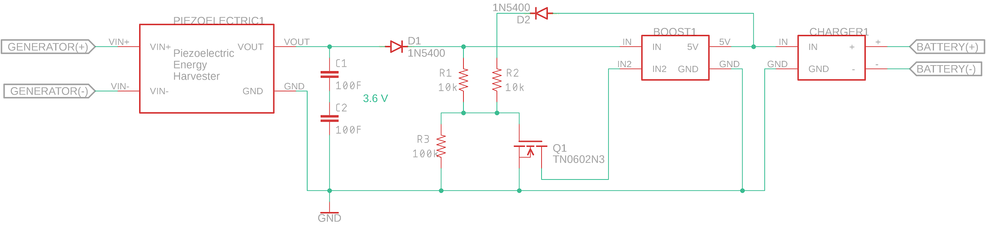

**Figure 6.** Schematic for the charging circuit

Alongside the point absorber generator that was manufactured, we implemented a rectifying circuit between the wave power generator and the battery that allows for safe charging. Our circuit consists of a piezoelectric energy harvester, 2 supercapacitors, resistors, a NMOS, a boost converter and a battery power management board. The way it works is that the piezoelectric energy harvester is connected to two super capacitors connected in series, which will store the power being supplied from the point absorber until they hit a certain threshold. Once that happens, the switch will close allowing for the super capacitors to discharge. This will then send power to the boost converter, then to the battery power management board, which will light up verifying that the battery is being charged, and allow safe charging.

With all that being said, the design implemented in this project could have further improvements to be made on it since we were only able to charge a single 3.7V battery cell. For example, due to the scale of our project, it will not be enough to charge a 30V battery as targeted; however, our design could produce that type of voltage in the future by supplying more magnets into the magnet holder design and wrapping more coil within the outside copper doughnut design. By adding more magnets into the holder, the design will increase in size; therefore, giving more surface area for the copper to interact with. In addition, with the addition of more wrapped magnetic copper wires, the power generated from this device would substantially increase as a result.

In Figure 7, the power connections are shown. The battery will be charged with the wave power generator through the rectifying circuit. The battery will feed power through the DC 12V converter for the winch and through the DC 5V converter to power the RPi and compass. Finally, the LoRa radio will be powered through a 3.3V line from the RPi.

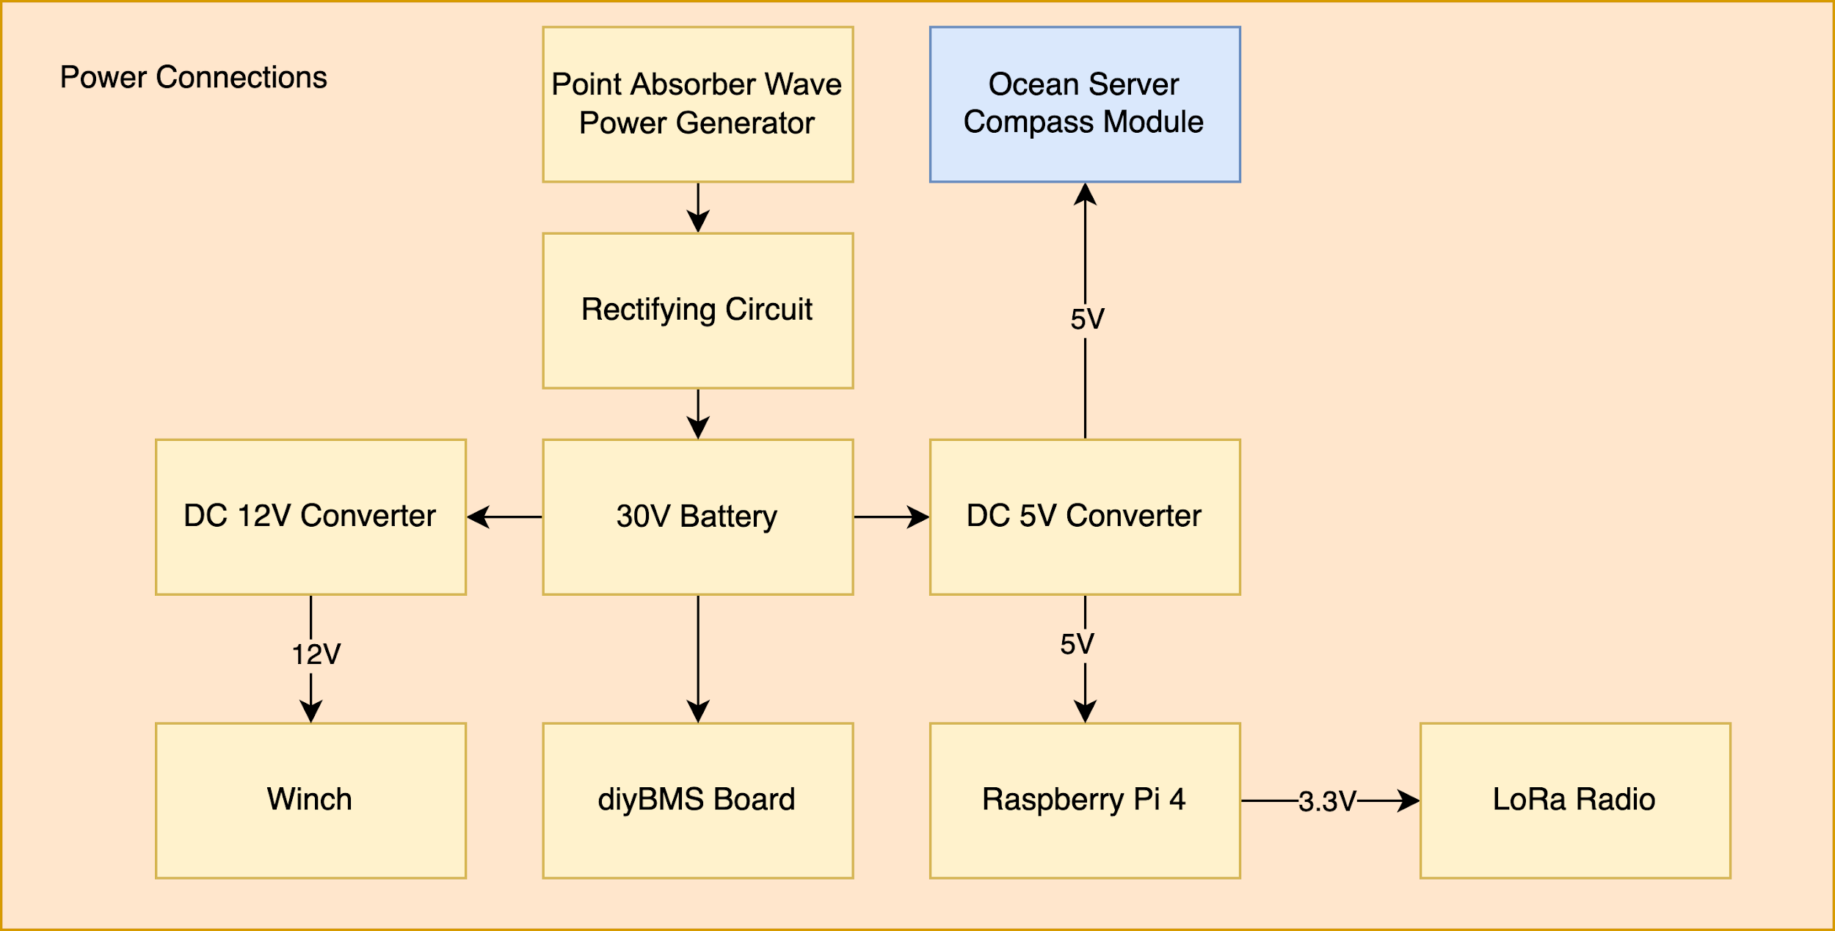

**Figure 7.** Block diagram of the power connections in the prototype

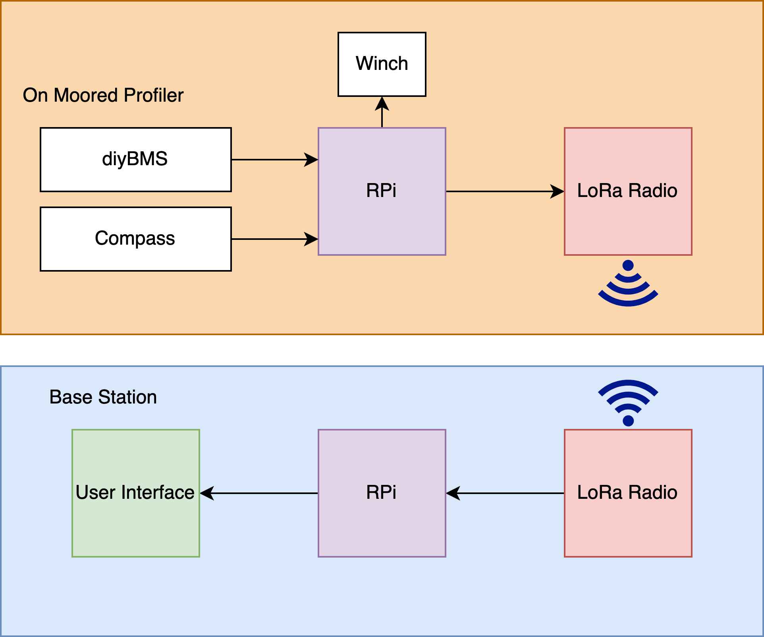

**Figure 8.** Block diagram of the data monitoring system of the prototype

The data monitoring system was the system used to collect data from the battery cell and digital compass, store it, relay it over the LoRa radio, and display it on a user interface. In Figure 7, the data monitoring system on the profiler and base station are shown. A RPi on the profiler stores data from the diyBMS and compass as well as commanding the winch. It then sends that data to the LoRa radio for transmission to the base station. At the base station another LoRa radio receives the data and passes it to a RPi which will store the data as well as display it on a user interface.

Communication is not the main focus of this project but is an aspect that is important to be present in the final product based on the needs of our customer. As a result, we have looked for an easily accessible option that can be rapidly implemented to our current design. The component we have decided to employ is the Adafruit LoRa Radio Bonnet with OLED - RFM95W @ 915MHz - RadioFruit. The device adds a LoRa / LoRaWAN radio to the RPi. It also includes a 128x32 OLED display to ease debugging and functionality verification which is connected to the device via the I2C communication bus. The device allows for 868MHz to 915MHz transmission/reception and can be tuned dynamically. Its transmission range can be greatly expanded with simple antennas, so this is a part that would have to be upgraded in a future deployment. With directional antennas it could transmit up to 20 kilometers. Another major reason we have decided to use the Adafruit LoRa Radio Bonnet is there are ready-to-go CircuitPython libraries to aid in software development for this device [17].

The Raspberry Pi 4 has been chosen for this project. We have considered other processors such as the ODROID, and other RPi models, but have ultimately decided to use the RPi 4 because of our past experience with RPi and the wealth of publicly accessible knowledge and examples that exist for the RPi platform. The upgraded processor on the RPi 4 was attractive for this application due to the machine learning that would be integrated in the future as well as the number of serial connections available.

A digital compass is a sensor that provides information about azimuth, pitch angle, roll angle, temperature, depth, magnetic vector length, acceleration vector length, 3 axis acceleration readings, 2 axis Gyro Output, etc. [24]. The information that is outputted from the compass is in the form of sentences at a fixed rate. This data will be sent to the Raspberry Pi over a serial interface. The data received on RPi will be parsed to obtain different parameters and values. That data will be stored in a ‘.txt’ file. We read in the data from the file and display it on a user interface.

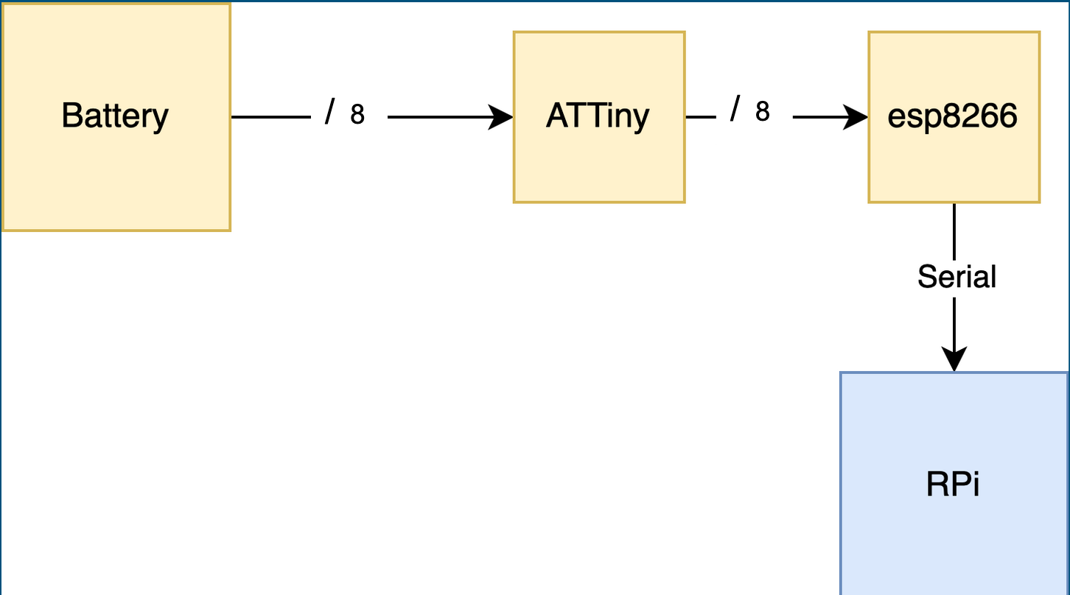

**Figure 9.** Block diagram of communication between battery and Raspberry Pi

The diyBMSv4 system made by Stuart Pittaway will be used for battery management and communication. It is used as a battery monitoring system on our prototype moored profiler. It includes ATTiny boards for each battery cell which then report data such as temperature and voltage to an ESP8266 microcontroller. The software/hardware for this system is included with the diyBMS system. The part we will be constructing is a serial bridge from the ESP8266 (WEMOS) microcontroller to the RPi. The ESP8266 dumps data about each battery cell over the bridge each time a packet is received and the RPi will transmit this data over the LoRa radio when communication can be established. Just like the digital compass, the data will be parsed and stored in ‘.txt’ files for user access or to be read in by the GUI.

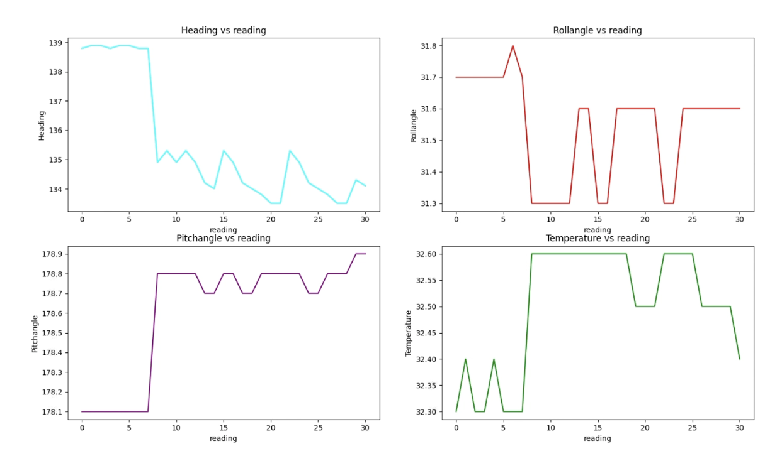

**Figure 10.** GUI display of digital compass data

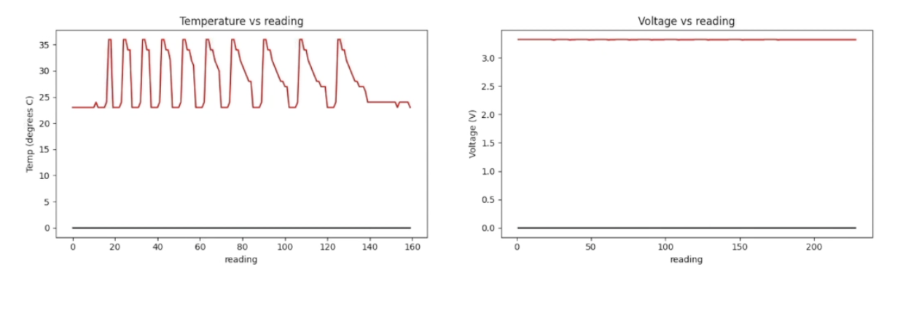

**Figure 11.** GUI display of battery cell data

The user interface is written in Python and it connects the RPi to the user. The interface will be running on RPi since it will be displaying the data obtained from the radio. When run, the interface shows two figures, one for data from the digital compass, as shown in Figure 10, and one for the battery cells, as shown in Figure 11. A heat gun was used to raise the temperature which is why the temperature is changing drastically in Figure 11. The GUI program will check the ‘.txt’ files for new data and display new data as it comes in. There is an existing bug where the figure for the battery cells will sometimes not update.

## 4.2 Codes and Standards

Relevant codes and standards include:

* LoRa, which short for long range, is a long range, low power wireless platform that is used widely in the Internet of Things applications [16]
* SPI, Serial Peripheral Interface, is the communication interface for the LoRa Radios
* Serial is the standard that will be used for communication with the battery management system along with many of the future sensors
* I2C, Inter-Integrated Circuit, is the communication bus used to show information on the LoRa radios’ display screens.

## 4.3 Constraints, Alternatives, and Tradeoffs

**Constraints - Power/Energy Source for the PWS Autonomous Moored Profiler**

Using a point absorber as a method to generate power/energy to the PWS Autonomous Moored Profiler could have the following constraints:

* The power from the point absorber is dependent upon wave motion.
* Any small garbage, object or animal can be struck between the spar and float, which could allow the point absorber to be unable to generate power or unable to provide enough power for the profiler.

**Alternatives - Power/Energy Source for the PWS Autonomous Moored Profiler**

There are many alternative methods that the PWS Autonomous Moored Profiler can be recharged with other than using a point absorber for a wave power converter. Besides the point absorber, we could have employed other wave power converters, such as attenuators and submerged pressure differentials.

1. **Attenuators/Linear Absorbers**

Attenuators, or linear absorbers, are wave energy converters that are oriented parallel to the direction of wave travel. Usually they’re modular in design and rely on the flexing of joints to generate power. Their design looks similar to two barges that are linked together, or in some cases, a sea snake. These devices try to capitalize on several different translations of motion; such as surge, sway, and heave as examples [15]. These converters are placed parallel to the force and direction of a wave. The motion of the device is from the crest and trough of the wave exerts force on a turbine that then feeds energy into the grid [5]. The wave attenuator was actually our first choice; however, based on physical experimentation on the initial design, we concluded that it would not generate enough power for the situation at hand.

**Figure 12.** Example of attenuator [5]

1. **Submerged Pressure Differential**

Submerged pressure differential comes in two different types. In one type, the device rests on or near the seafloor and relies on pressure fluctuations as a wave passes overhead to flex a pliable material such as an air bladder and squeeze a fluid to drive a turbine or some other power take-off unit. The other type is similar to a point absorber, but in this type, a buoyant, submerged float is actuated by passing waves and this reciprocating motion is converted to energy with a linear generator [15]. This type is shown below. The reason the team did not pursue this topic was because this model would require the prototype to be in shallow water, unlike in PWS, and rest on the seafloor.

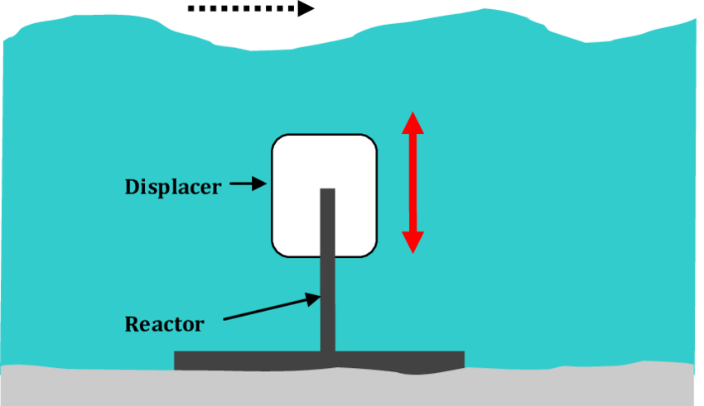

**Figure 13.** Example of submerged Pressure Differential

Other than using wave energy, the PWS Autonomous Moored Profiler could have been recharged with different renewable energy methods, such as solar energy and wind energy, which we have considered as well.

1. **Solar Energy**

Solar energy is not our primary choice for generating energy because there are many limitations and disadvantages compared to the wave power converters. For example, solar energy is very weather and time dependent. Therefore, energy cannot be generated at night or when there is a snow or rain or a storm. Specifically, the intensity of daylight is poor in Prince William Sound. In addition, a solar panel degrades over time; therefore, a solar panel can usually be used between 20-25 years before the panel has lost all of its efficiency [2]. The efficiency of a solar cell will degrade around 5-10% each year [8]. Furthermore, the solar panels can be easily damaged in the environment proposed. However, solar energy could be implemented in conjunction with wave energy in a future design to generate more power.

1. **Wind Energy**

Wind energy is also not our primary choice because it would require significant modifications to the nearby buoy, which is not in the scope of this project. A large turbine could also lead the buoy to be less stable. Wind energy is also less consistent than wave energy [8]. However, wind energy could be implemented in conjunction with wave energy to produce more power in the future.

**Tradeoffs - Power/Energy Source for the PWS Autonomous Moored Profiler**

**Table 2.** Point Absorber Pros and Cons

|  |  |
| --- | --- |
| **Point Absorber vs. Attenuator and Submerged Pressure Differential** | |
| Pros | 1. Design is much simpler to implement 2. Considerably easier to use and cheaper to make 3. Being a standalone device or an added device to the current profiler |
| Cons | 1. Required a lot of spaces in vertical plane (from the surface to seabed) 2. Structure could be eroded and degraded by saltiness of seawater; therefore, damaging the system |
| **Wave Power vs. Solar and Wind Energy** | |
| Pros | 1. Relatively safer to be installed in the ocean 2. Waves are hardly interrupted and almost always in motion; therefore, more reliable 3. Potential amount of power that comes in waves are huge (roughly 30-40 kW for every meter) |
| Cons | 1. Harder to maintain as wave energy converter is larger in scale 2. Due to the scale of the wave energy converter, engineers would potentially have to disassemble the point absorber by pieces to do maintenance 3. Costs of wave power are generally very high |

Based on the pros and cons listed in Table 2, the point absorber wave power generator has a more feasible design to manufacture and experiment upon with the given constraints surrounding this project. With the skillset of the group and resources at hand, the point absorber seems to have more of an advantage compared to the other alternatives as it will not require us to innovate pre-existing systems currently in place; therefore, it'll theoretically be an add-on that can easily be deployed near the current location of the profiler.

**Data Monitoring Constraints/Alternatives/Tradeoffs**

Each component of the data monitoring system also had constraints, alternatives, and tradeoffs as well.

The Adafruit LoRa Radio Bonnet module has many constraints and could probably not be used as is for the final module for communication but serves as a good example for a prototype. Some constraints include:

* By itself can only transmit 2 Km in line of sight
* Not as fast as WiFi, Bluetooth, or some cellular
* Does not maintain a link/pairing like WiFi or Bluetooth

**Table 3.** RPi Tradeoffs

|  |  |  |  |  |  |
| --- | --- | --- | --- | --- | --- |
|  | **RPi 4** [7][18] | **RPi 3 B+** [7][18] | **RPi 3** [7][18] | **Odroid C4** [9] | **BeagleBone Black** [4][18] |
| Power at idle | 540 mA  (2.7 W) | 350 mA  (1.9 W) | 260 mA  (1.4 W) | 1.9 W | 290 mA (1.45 W) |
| 400% CPU load | 1280 mA  (6.4 W) | 980 mA  (5.1 W) | 730 mA  (3.7 W) | 3.1-3.3 W | - |
| Clock Speed | 1.5GHz | 1.4GHz | 1.4GHz | 2.0 GHz | 1.0 GHz |
| RAM | 1GB/2GB/4GB | 1GB | 1GB | 4GB | 512 MB |
| Serial Connections | 6 | 2 | 2 | 2 | 5 |

Overall, based on Table 3 above, the ODROID C4 has a higher clock speed and more RAM by default, but no one in the group is familiar with the system and the learning curve, and possibly lead time, could be significant. The other advantage of using a RPi denomination is that both the senior design lab and The Hive have Raspberry Pi 3, 3B+, and 4 in stock so we can begin development immediately. The Hive also has BeagleBone Black’s, but the set-up is more difficult, and the performance is lower. Additionally, in past courses such as ECE 4180 embedded development has been performed on the RPi, so we know this kind of development is possible. Finally, for future sensor integration the RPi lends itself better to sensor integration because it has the highest number of serial connections available, plus USB connectors that could be integrated with RS232 to USB connections. The chart in the appendix shows the current sensors and their communication protocols, showing that seven serial connections are needed, which is possible on the RPi 4 through the use of hats and USB connections.

# 5. Schedule, Tasks, and Milestones

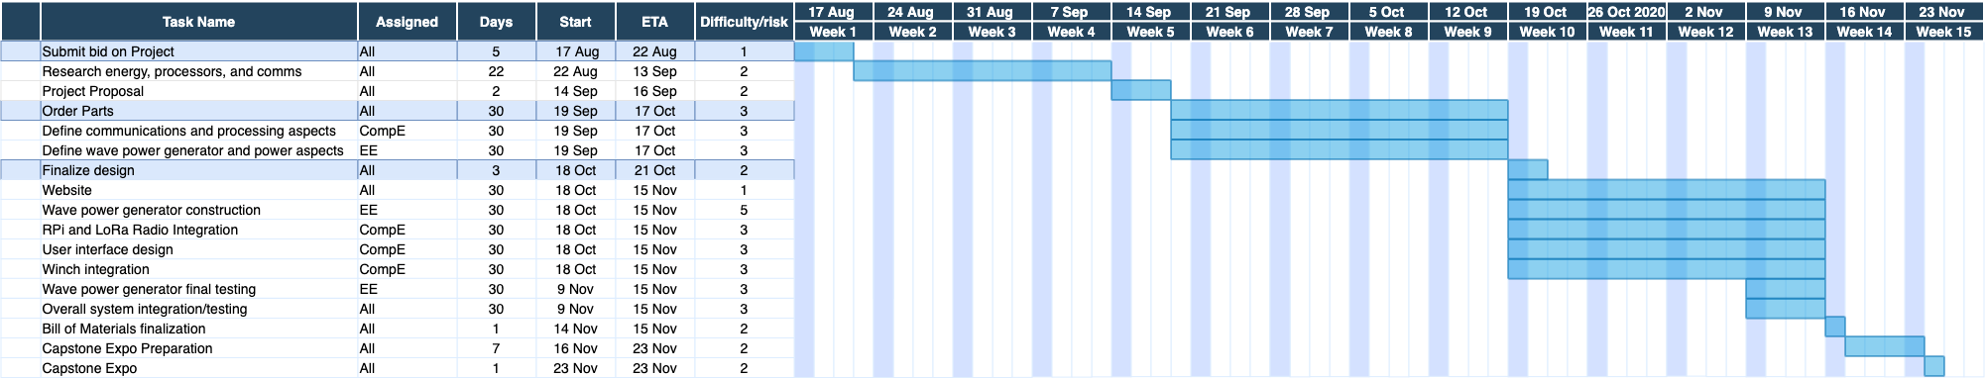

**Figure 14.** Gantt Chart

Assignment of the tasks followed each member’s major. Aspects of the project related to software such as the communication module and winch/radio integration were assigned to the computer engineers on the team, while the electrical engineers focused on the physical wave power generator. Various tasks were collaborative efforts between all members, which included logistics, documentation, overall system integration and capstone related activities.

Below are the specific contributions of each team member towards their major goal. This does not include tasks that all group members worked on collectively.

Rahil Ajani (EE): Designing charging circuit, point absorber generator, constructed all devices, and testing

Srushty Changela (CompE): User interface design, data monitoring module integration

Kombundit Chitranuwatkul (EE): Charging circuit and point absorber generator design

Nicholas Nguyen (CompE): LoRa radio/winch integration, data monitoring module integration, website

Richard Nguyen (EE): Charging circuit and point absorber generator design, CAD all materials used, constructed all devices, and testing

Celeste Smith (CompE): diyBMS battery board integration, data monitoring module integration

# 6. Final Project Demonstration

On the power generation side, we demonstrated and validated this project by using laboratory instruments and putting together the manufactured point absorber and charging circuit. The following were done to test these devices:

* An independent DC power supply was hooked onto our charging circuit with a constant charge of roughly 6V to showcase the charging circuit was functioning properly, which would be indicated by a LED being lit up on the battery power management board. The battery charger chip within the circuit required a 5V input which was met due to the boost converter and allowed the battery to charge.
* An oscilloscope was hooked into our point absorber generator to showcase and validate power being generated from the point absorber by moving the outer copper doughnut up and down the PVC pipe along the magnets from within.
* With confirmation of power being generated, the point absorber was soldered onto the piezoelectric energy harvester, which is connected to the rest of the charging circuit, and used to generate power to the charging circuit until the battery power management board lit up - indicating that a safe charging sequence has indeed begun to the battery.
* The data received from the battery cells through the battery management system and the compass were collected and stored in a text file and displayed on a graphical user interface successfully.

For the data monitoring system, we made sure data was being sent and received through the use of print statements and eventually by showing the data on the user interface. We validated that the correct voltage was being measured by reading it in and measuring on a multimeter. During the final project demonstration we showed the devices collecting data (verified through print statements), the winch deploying and rewinding (verified visually), the data being transmitted (through the displays on the LoRa Radios and print statements), the data being received (through the displays on the LoRa Radios and print statements), and the user interface showing the data and automatically updating (visually).

For the last step, we hooked the power generation system up to the data monitoring system, by hooking the battery cell to the rectifying circuit and diyBMS. Then we moved the wave power generator to charge the batter and monitored the charge on the user interface. This can be seen the the project video linked below.

Links to external documentation

* Project video: <http://ece4873y202008.ece.gatech.edu/sd20f27/Video.html>
* For diagrams/schematics/datasheets: <http://ece4873y202008.ece.gatech.edu/sd20f27/documentation.html>
* For code base and code guide: <https://github.com/csmith608/ScientificShark>

# 7. Marketing and Cost Analysis

## 7.1 Marketing Analysis

In this project, we designed our own unique point absorber in order to prove the concept of being able to charge the battery on the PWS Autonomous Moored Profiler on a small scale using smaller parameters that will be able to be manipulated in future uses on a larger scale. With that being said, there are several existing ideas and products that we could use their ideas and design to aid the design of our point absorber, such as the AquaBuOY.

The current most popular existing product of the point absorber is the AquaBuOY, manufactured by AquaEnergy Development UK Limited (a subsidiary of Finavera Renewables) [19]. AquaBuOY is a freely floating heaving point absorber, reacting against a submersed reaction tube (mass of water). The reaction mass is moving a piston assembly which drives a steel reinforced elastomeric water pump (hose pump). The hose pump pushes water on a high-pressure level. An accumulator is used to smooth the power output and the pressure head is then discharged onto an impulse turbine to generate electricity. Grid synchronization is achieved using a variable speed drive and step-up transformer to a suitable voltage level. The manufacturer of AquaBuOY stated that a device is able to produce 250 kW of energy, with an associated capacity factor of about 12% (assuming a 25kW/m wave climate). It is predicted that a capacity factor of around 40% could provide a near optimal economic value of electrical energy for this type of a device [21].

**Figure 15.** AquaBuOY by AquaEnergy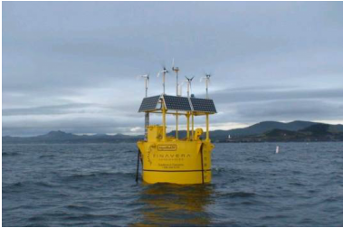

Due to the fact that the profiler requires very low energy, 1.5 kWh, to operate, our designed project will only need to generate a smaller amount of the energy. Therefore, our design of the point absorber will be much smaller in size than the products from the current market.

## 7.2 Cost Analysis

**Table 4.** Cost for each part

|  |  |  |  |
| --- | --- | --- | --- |
| **Topics** | **Materials** | **Quality** | **Total Price** |
| Power Generator | Temflex 3/4 in. x 60 ft. 1700 Electrical Tape Black | 1 | $1.78 |
|  | Rare Earth 3/4 in. x 1/4 in. Disc Magnet (4-Pack) | 12 | $190.42 |
|  | 2 in. PVC Schedule 40 S x S Coupling | 2 | $1.96 |
|  | 2 in. x 24 in. PVC Sch. 40 DWV Pipe | 1 | $4.96 |
|  | 16 oz. Gaps and Cracks Insulating Foam Sealant with Quick Stop Straw | 1 | $4.08 |
|  | J-B W Clearweld Epoxy Syringe 25 mL | 1 | $19.50 |
| Battery Communication | Raspberry Pi 4 15W Power Supply | 1 | $8.47 |
| Radio Communication | Adafruit LoRa Radio Bonnet with OLED | 2 | $80.22 |
|  |  | Total | **$311.39** |

The total budget of this prototype is $700. Based on our prices, we are under budget with a total cost of $311.39. However, many items such as the two Raspberry Pi’s, 3D printed items, and circuit parts were provided at no cost by the labs at Georgia Tech.

Cost of labor:

Hours spent = ~9 hours/person

Weeks spend = ~12

Dollars per hour = ~38

Members of the group = 6

Cost of labor = ~$24,624

The selling price of these prototypes will not be listed due to these prototypes have been designed and built for a specific machine: PWS Autonomous Moored Profiler.

# 8. Conclusion

This semester we were able to build a working point absorber wave power generator, along with a data monitoring system, and GUI. We were not able to test the wave power generator with actual waves, but received these results be moving the device by hand as shown in the video in the appendix:

* Our point absorber generator was able to generate roughly a minimum of about 3.5V at a steady motion and a maximum of 10V.
* The output from the battery charging circuit was 4.2V and 500mA. The battery used on the prototype was 2200mAh and would theoretically take 4.4 hours to charge.

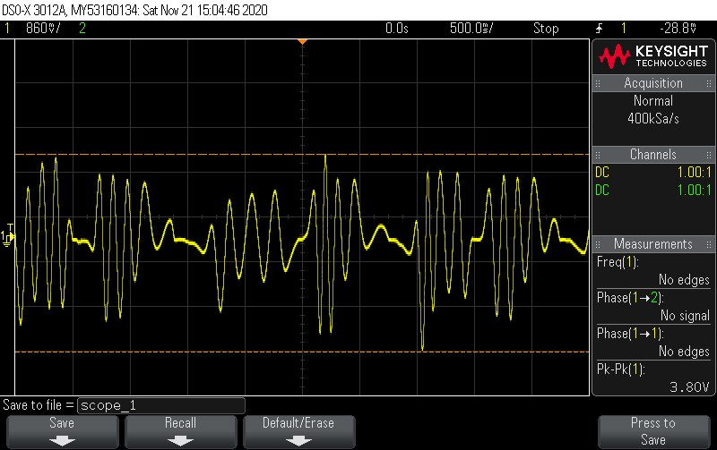

**Figure 16**. Oscilloscope capture of point absorber generator at steady motion

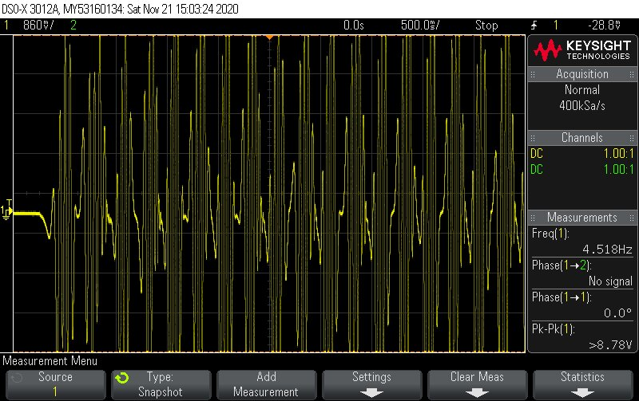

**Figure 17.** Oscilloscope capture of point absorber generator at rapid motion

The design implemented in this project could have further improvements to be made on it since we were only able to charge a single 3.7V battery cell. For example, due to the scale of our project, it will not be enough to charge a 30V battery as targeted; however, our design could produce that type of voltage in the future by supplying more magnets into the magnet holder design and wrapping more coil within the outside copper doughnut design. By adding more magnets into the holder, the design will increase in size; therefore, giving more surface area for the copper to interact with. In addition, with the addition of more wrapped magnetic copper wires, the power generated from this device would substantially increase as a result. A future group could also test the prototype in a more realistic environment, first in a wave tank, then in the ocean.

For the data monitoring system, we had data flowing from the diyBMS and compass into the Raspberry Pi which stored it and sent it over the LoRa Radio, which was then received by the base station LoRa Radio and displayed on a user interface. This process can be seen in the video in the Appendix as well as described in Section 6. The radios were taken outside and tested to 2 Km line of sight. A more extensive user guide on the codebase is include here: <https://github.com/csmith608/ScientificShark/blob/main/README.md>

Future groups could add on to the user interface to add support for other sensors and add code to parse through different sensor data. They could also add additional error checking that was not possible this semester. Another area for improvement would be adding antennas to the LoRa radios for additional range or switching out the antennas for more specialized equipment.

# 9. Leadership Roles

Our currently defined leadership roles are:

* Group Leader: Celeste Smith
  + Coordinate meetings and serve as spokesperson
* Webmaster: Nicholas Nguyen
  + Have the key to the website and be in charge of deploying information to the website
* Documentation Coordinator: Srushty Changela
  + In charge of making sure we are taking and maintaining the necessary documentation
* Expo Coordinator: Rahil Ajani
  + Coordinate everything for our group to present at the expo
* Financial manager: Richard Nguyen
  + In charge of reimbursements and keeping track of costs
* Power Lead: Kombundit Chitranuwatkul
  + Lead on the electrical engineering/power engineering side of the project

# 

# 10. References

1. “About - Prince William Sound Science Center.” Prince William Sound Science Center. <https://pwssc.org/about/> (accessed September 14 2020).
2. “About Solar Energy | SEIA.” Solar Energy Industries Association. <https://www.seia.org/initiatives/about-solar-energy> (accessed September 13, 2020).
3. “Attenuator - Analysis of Cost Reduction Opportunities in the Wave Energy Industry.” University of Strathclyde. <http://www.esru.strath.ac.uk/EandE/Web_sites/14-15/Wave_Energy/attenuator.html> (accessed September 14, 2020).
4. “BeagleBone Black.” Beagle Board. https://beagleboard.org/black. (accessed September 15, 2020).
5. “Energy And The Environment-A Coastal Perspective - Attenuators.” Coastal Energy And Environment.web.unc.edu. [http://coastalenergyandenvironment.web.unc.edu/ocean-energy-generating-technologies/wave-energy/the-pelamis-wave-energyconverter/](http://coastalenergyandenvironment.web.unc.edu/ocean-energy-generating-technologies/wave-energy/the-pelamis-wave-energy-converter/) (accessed September 13 2020).
6. Faizal, M., Ahmed, M. and Lee, Y., “A Design Outline for Floating Point Absorber Wave Energy Converters,” *Advances in Mechanical Engineering*, vol. 6, Feb. 15, <https://journals.sagepub.com/doi/10.1155/2014/846097> (accessed September 13, 2020).
7. J. Geerling. “Power Consumption Benchmarks.” Raspberry Pi Dramble. <https://www.pidramble.com/wiki/benchmarks/power-consumption> (accessed September 13, 2020).
8. Talaat, M., Farahat, M.A. and Elkholy, M.H., “Renewable power integration: Experimental and simulation study to investigate the ability of integrating wave, solar and wind energies,” *ScienceDirect*, vol. 170, pp. 668-682, Mar. 2019, <http://www.sciencedirect.com/science/article/pii/S0360544218325453>.
9. “ODROID-C4.” ODROID. <https://www.hardkernel.com/shop/odroid-c4/> (accessed September 15, 2020).
10. “Prince William Sound Recent Marine Data” NDBC. <https://www.ndbc.noaa.gov/maps/Alaska_inset.shtml> (accessed September 14, 2020).
11. R. Campbell, “A Profiling Observatory for High Resolution Oceanographic, Biogeochemical, and Plankton Observations in Prince William Sound.“ *Prince William Sound Science Center.* [Online]. Available: <https://drive.google.com/file/d/1uin5A8rl6_Gcp6-w-3mS5BZkiQ6HwGLV/view> (accessed September 14, 2020).
12. “The Basics of Wind Energy | AWEA.” American Wind Energy Association. <https://www.awea.org/wind-101/basics-of-wind-energy> (accessed September 13, 2020).
13. “The Prince William Sound Plankton Camera: a profiling in situ observatory of plankton and particulates.” ICES Journal of Marine Science. <https://drive.google.com/file/d/1-PuFgZ_EeXKMH_uZcOuvVcdq-dWTjals/view> (accessed September 14, 2020).
14. “Thetis Profiler.” Sea-Bird Scientific. <https://www.seabird.com/systems/thetis-profiler/family?productCategoryId=54627869948> (accessed September 13, 2020).
15. “Wave Energy Converters - The Liquid Grid.” The Liquid Grid. <https://theliquidgrid.com/marine-clean-technology/wave-energy-converters/> (Accessed 13 September 2020).
16. “What is LoRa®?.” Semtech. <https://www.semtech.com/lora/what-is-lora> (accessed September 13, 2020).
17. “Adafruit LoRa Radio Bonnet with OLED - RFM95W @ 915MHz.” Adafruit. <https://www.adafruit.com/product/4074> (accessed September 13, 2020).
18. “UART Configuration.” UART Configuration - Raspberry Pi Documentation. [www.raspberrypi.org/documentation/configuration/uart.md](http://www.raspberrypi.org/documentation/configuration/uart.md) (accessed September 16, 2020).
19. Lemos, E., Haraczy, N. and Shah, A., “Estimating the Generating Efficiency of the AquaBuOY 2.0,” *ResearchGate,* October 2018, <https://www.researchgate.net/publication/328281087_Estimating_the_Generating_Efficiency_of_the_AquaBuOY_20>
20. Li, Y, and Yu, Y., “A synthesis of numerical methods for modeling wave energy converter-point absorbers,” *ScienceDirect*, vol. 16, pp. 4352-4364, August 2012, <https://www.sciencedirect.com/science/article/abs/pii/S1364032111005351>
21. “Point Absorber - Analysis of Cost Reduction Opportunities in the Wave Energy Industry.” University of Strathclyde. <http://www.esru.strath.ac.uk/EandE/Web_sites/14-15/Wave_Energy/point-absorber.html> (accessed October 26, 2020).
22. L. Guthrie, *Energy and the Environment-A Coastal Perspective*, 31-May-2010. [Online]. Available: http://coastalenergyandenvironment.web.unc.edu/ocean-energy-generating-technologies/wave-energy/the-pelamis-wave-energy-converter/. [Accessed: 05-Dec-2020].
23. N. Tom, Y.-H. Yu, and A. Wright, “Submerged Pressure Differential Plate Wave Energy Converter with Variable Geometry ,” *NREL.gov*, 06-Sep-2019. [Online]. Available: https://www.nrel.gov/research/publications.html. [Accessed: 05-Dec-2020].
24. Ocean Server, “Digital Compass Users Guide, OS5000 Series,” OS5000 datasheet, ND

# 

# Appendices

* Project mission: <http://ece4873y202008.ece.gatech.edu/sd20f27/index.html>
* For deliverables: <http://ece4873y202008.ece.gatech.edu/sd20f27/about.html>
* Project video: <http://ece4873y202008.ece.gatech.edu/sd20f27/Video.html>
* For diagrams/schematics/datasheets: <http://ece4873y202008.ece.gatech.edu/sd20f27/documentation.html>
* For code base and code guide: <https://github.com/csmith608/ScientificShark>

# 

|  |  |  |
| --- | --- | --- |
| Instrument | Link | Communication Protocol |
| Seabird FASTCAT | <https://www.seabird.com/asset-get.download.jsa?id=54627862103> | RS-232 |
| RBR brevio | <https://rbr-global.com/products/standard-loggers/rbrbrevio> | RS-232 |
| Seabird Eco FLNTU | <https://www.seabird.com/combination-sensors/eco-flntu/family?productCategoryId=54758054352> | RS-232 |
| Seabird SBE 63 | <https://www.seabird.com/oxygen-sensors/sbe-63-optical-dissolved-oxygen-sensor/family?productCategoryId=54627869933> | RS-232 |
| Aanderaa Optode | <https://www.aanderaa.com/productsdetail.php?Oxygen-Optodes-2> | CANBus and RS-232 |
| Seabird SUNA | <https://www.seabird.com/nutrient-sensors/suna-v2-nitrate-sensor/family-downloads?productCategoryId=54627869922> | Serial |
| Plankton cam |  | Serial |