**Prince William Sound Underwater Profiling Vehicle**

ECE4873 D1A - Senior Design Project 2

Team Name: Scientific Shark

Project Faculty Advisor: Dr. Michael E. West

**Scientific Shark:**

Rahil Ajani, EE, rajani3, rahilajani@gatech.edu

Srushty Changela, CmpE, schangela3, srushty@gatech.edu

Kombundit Chitranuwatkul, EE, kombundit3, kombundit3@gatech.edu

Nicholas Nguyen, CmpE, nnguyen99, nnguyen99@gatech.edu

Richard Nguyen, EE, rnguyen36, richardvnguyen@gatech.edu

Celeste Smith, CmpE, csmith608, celestesmith@gatech.edu

Submitted

10/28/2020

**Executive Summary** **2**

**Nomenclature** **4**

**1. Introduction** **5**

**2. Project Description, Customer Requirements, and Goals** **7**

**3. Technical Specifications** **12**

**4. Design Approach and Details** **13**

4.1 Power Generation Technical Details 13

4.1.1 Design Concept Ideation 13

4.1.2 Design Concept Constraints 15

4.1.3 Design Concept Alternatives 15

4.1.4 Design Concept Tradeoffs 18

4.1.5 Final Design for Power/Energy Generation 19

4.2 Computing Aspects 20

4.2.1 Communication Module 20

4.2.2 Processor 20

4.2.3 Compass 22

4.2.4 Battery Communication 22

4.2.5 User Interface 23

4.3 Engineering Analyses and Experiment 25

4.4 Codes and Standards 26

**5. Schedule, Tasks, and Milestones:** **26**

**6. Project Demonstration** **27**

**7. Marketing and Cost Analysis** **28**

**8. Current Status** **30**

**9. Future Improvements** **31**

**10. Leadership Roles** **32**

**11. References** **33**

**Appendix** **36**

# **Executive Summary**

In 1989 an Exxon oil tanker ran aground, spilling more than 11 million gallons of oil into the Prince William Sound [1]. After cleanup efforts damaged the ecosystem even further, Exxon began funding research efforts in the sound that allow for monitoring of the ecosystem and restoration efforts. The scientists currently used a moored profiler that was made by Sea-Bird Scientific which they have added instruments such as a plankton camera. Sea-Bird Scientific has discontinued production and support for this profiler and the scientists have problems with the current system. They came to Dr. West over the summer and proposed the idea of designing a new profiler. The new system would overcome the biggest disadvantages of the current system and leave them with a system that they could extend to provide even more functionality in the years to come.

After speaking with the scientist we concluded that the biggest problems with the current design, and most important problems to solve in the new design were: first a way to remotely charge the battery, they current have to go out on a boat and pull the profiler out to charge it once a month; second lack of information that can be remotely communicated, they can only receive very simple telemetry, but would like to get scientific data.

Our group will build a prototype of a new moored profiler that will have a wave power generator that will trickle charge a 30V battery. It will have a long range radio for scientific data transmission. We will also have a digital compass as an example sensor and a winch. Finally, we will use a Raspberry Pi as the processor and include interfaces that can support the current instruments. The cost will be 280.89 dollars.

A future group will work to integrate the required instrumentation. They will also upgrade the processor to something more fit for this application and upgrade to use a more suitable radio for communications.

# Nomenclature

LoRa: Long Range, a low power long range communications device

PWS: Prince William Sound

RPi: Raspberry Pi

**Prince William Sound Moored Profiler Reimagining**

# 1. Introduction

The Prince William Sound autonomous moored profiler (PWS profiler) has provided vital data regarding the health of marine ecosystems in the Prince William Sound of the Gulf of Alaska. In response to the 1989 Exxon Valdez oil spill which decimated wildlife populations in the area, the PWS profiler has administered long-term monitoring to assess the still lingering effects of this environmental catastrophe [10]. Despite being an overall success, the profiler has a variety of pain points that have concerned its scientists and has prompted calls for improvement. Thus, our team: Scientific Shark is requesting $280.89 to develop a prototype for a new moored profiler that incorporates renewable energy in the form of a wave power generator which provides trickle charging to the device’s battery, as well as a communications box that will enable greater ranged data transmission capabilities.

The current system of the PWS profiler was created by Sea-Bird Scientific but has since been discontinued and support for the profiler suspended. It carries a Bluefin 1.5 kWh Subsea battery that must be manually charged by removing the entire profiler from the water once a month. This not only is tedious and cumbersome, but also takes away time from the water that may produce vital information. As opposed to the current design of the profiler, our group will implement a wave power generator into our prototype. This will provide a renewable, alternative energy source to the system without the need to remove the profiler from the sound.

To this end, a variety of other renewable energy sources were also considered, including solar and wind energy. The most prominent disincentive for using these sources, as well as a general challenge to overcome with designing a new profiler is the location itself. The Prince William Sound is located in the Gulf of Alaska, which can see extreme weather and high waves [1]. Any equipment attached to the exterior of the profiler such as a solar panel or wind turbine has a high probability of being destroyed or becoming detached, although a future improvement could use these to supplement the wave power. The way in which the wave power converter would be implemented was also subject to debate. While our group chose to implement a point absorber-based converter because of its existing example application in technologies similar to our prototype, both attenuator and submerged pressure differential wave converters could have also been employed.

In addition to the substandard battery charging methods, the PWS profiler also has a general lack of remote data transmission abilities. The current system can only communicate standard telemetry through a line of sight, high-bandwidth radio with a range of about 2-3 miles via a 900 MHz transmitter [13]. Our team will develop a prototype profiler with a communications box attached to the body of the profiler that will have high frequency and range data transmission capabilities, using a Raspberry Pi microcontroller as the processor. We will also incorporate interfaces that can support the current instrumentation. This will enable the remote transmission of data not only related to the status of the profiler, but also scientific data that has thus far been extracted from the device by taking it out of the water.

Other than introducing an alternative energy source, the aforementioned improvements that will be implemented to the prototype will most benefit the end user by making operation of the device much less hands-on. With these modifications, scientists can leave the profiler in the sound without the necessity to remove it from the sound once a month for charging or information extraction. This would allow for greater time periods of uninterrupted data acquisition and would save researchers the time and effort of physically travelling into Prince William Sound to pull the profiler out of the water.

The subsequent sections will provide a deeper understanding for our group’s revised profiler prototype. A description about the project, customer requirements, and goals will offer the necessary background on the device’s current operation and key issues. Next are the device’s Technical Specifications followed by the Design Approach, which details our motivation to revise the current profiler, the project’s constraints and tradeoffs, and quantitative engineering analyses among other key elements describing the production of the profiler. Finally, the last few sections are predominantly logistical, pertaining to the design team’s development, cost analysis, and presentation of the prototype.

# 2. Project Description, Customer Requirements, and Goals

Our team will be redesigning a marine resource management system using an automated ecosystem procedure [13]. A PWS profiler will be prototyped, which consists of a 30V battery that will be built by Dr. West, a communication system demonstrating higher bandwidth precise data, a point absorber wave generator, a digital compass, a winch, and a Raspberry Pi 4 processor with interfacing solutions that could be upgraded in the future to be lower power with higher processing ability. An initial prototype will be created which does not meet the exact requirements of the customer, such as a high enough transmission range, but the prototype could be improved to meet those requirements.

To allow for self-charging, we will be using the point absorber method to derive the wave energy and is potentially powerful enough to generate power for the current instruments such as the Seabird FASTCAT, RBR brevio, Seabird Eco FLNTU, Seabird SBE 63, Aanderaa Optode, Seabird SUNA, and plankton camera. The power generation required for the new system will incorporate point absorbers, which are wave energy converters that are made up from two primary parts: a spar that is moored to the seabed and floater/buoy that will move vertically according to waves. In a real implementation, the power generated from the converter will be connected via subsea cable and transferred to the profiler allowing trickle charging, in our prototype it will just be connected via a rubber wrapped cable. The alternatives for attenuators are other renewable sources such as solar and wind energy, and wave power converters like submerged pressure differential and point absorber. More detailed information about power/energy for the PWS autonomous moored profiler such as technical specifications, design ideation, constraints, and design alternatives is mentioned in the following sections of this proposal.

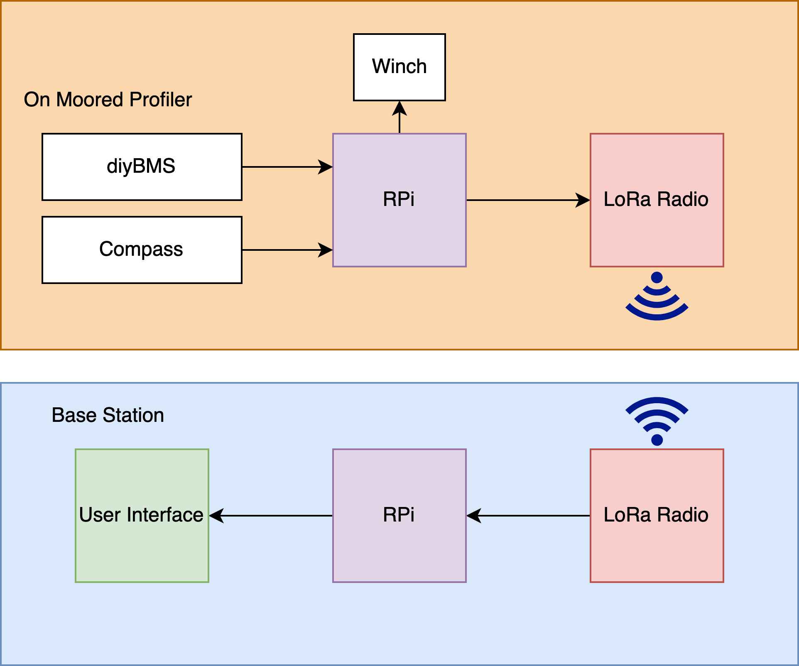

**Figure 1.** Block Diagram of the communications of the prototype

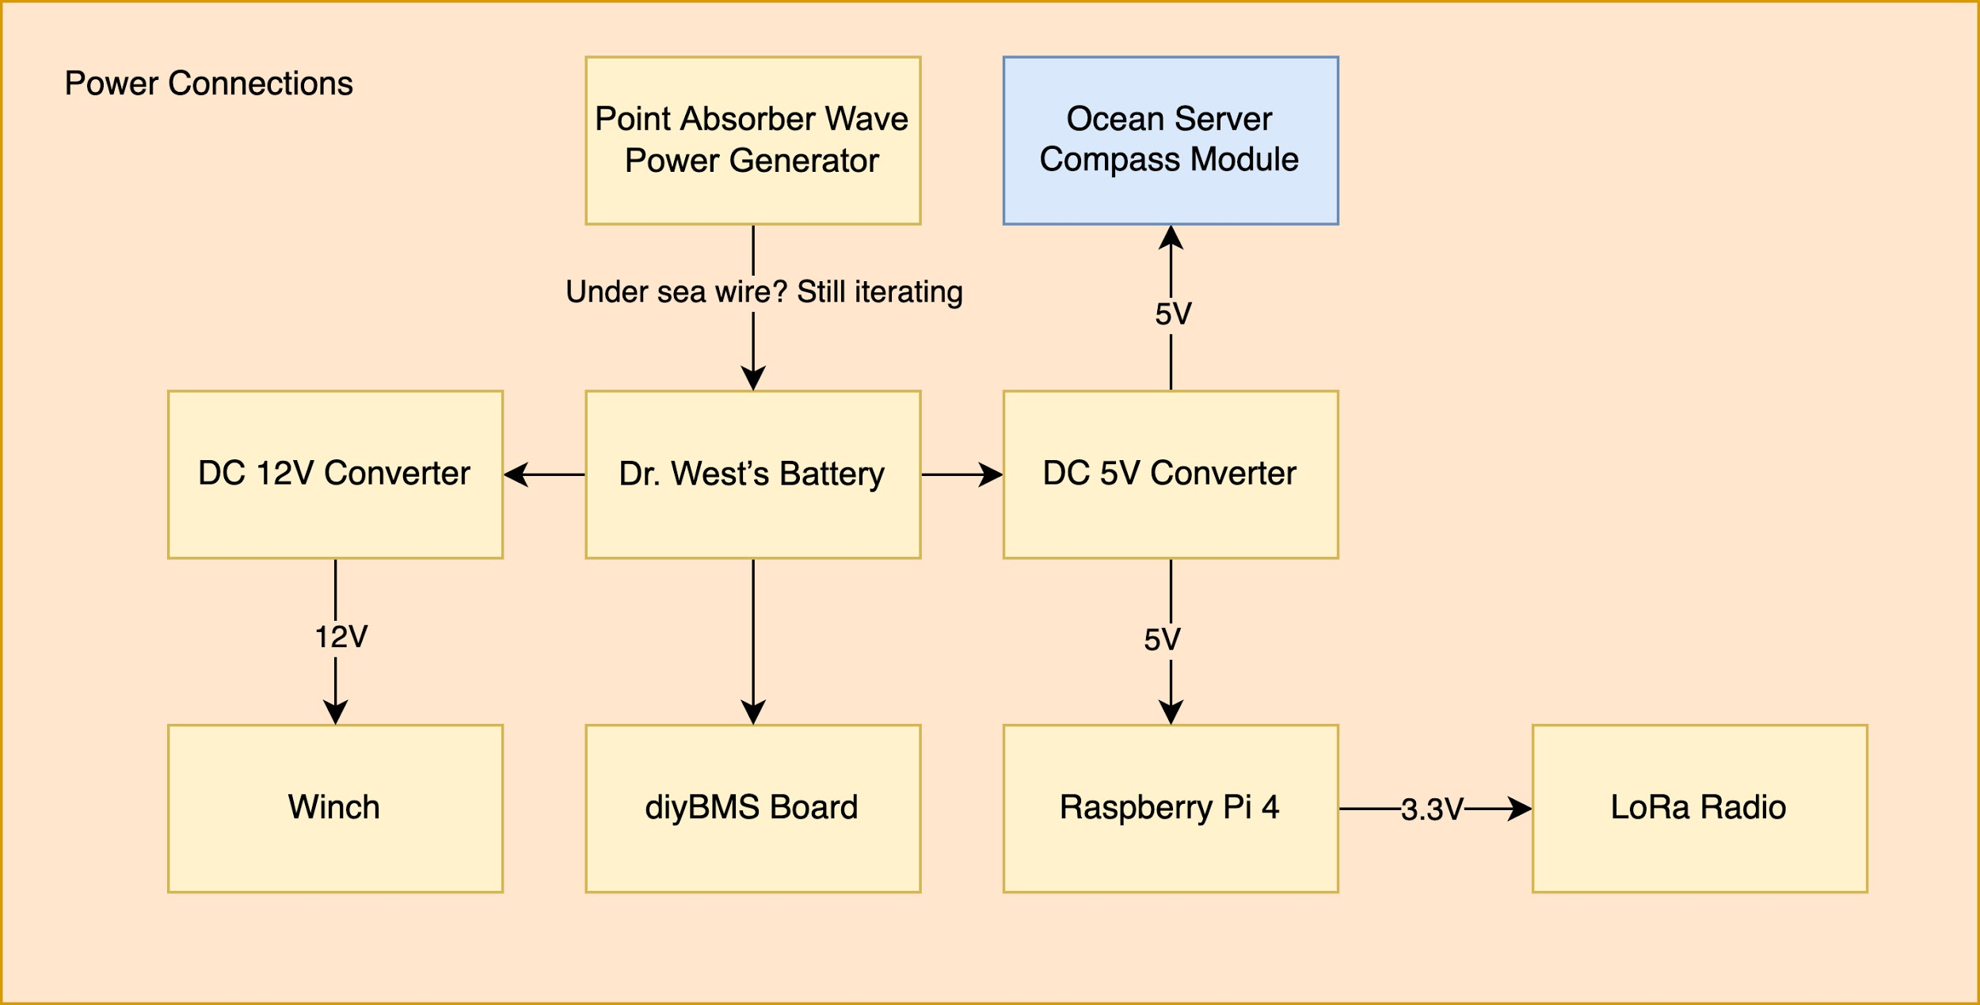

**Figure 2.** Block diagram of the power connections in the prototype

The communication systems will be equipped with a Raspberry Pi 4 processor to allow remote accurate data collection. The RPi processor will be able to communicate with the winch, compass, battery management system, and communications module through their respective communication interfaces. An Adafruit LoRa Radio Bonnet module will be the communications module, providing long range communication, alternatives were not considered, due to the scope of the project. This module will allow high bandwidth and precision data that can be collected remotely instead of collecting the data directly from the profiler at the location. We picked the Raspberry Pi processor as we have worked with this platform before so rapid development will be possible. In Figure 1, the communication connections are shown, a RPi on the profiler stores data from the diyBMS and compass as well as commanding the winch. It then sends that data to the LoRa radio for transmission to the base station. At the base station another LoRa radio receives the data and passes it to a RPi which will store the data as well as display it on a user interface. In Figure 2, the power connections are shown. The battery will be charged through the wave power generator which will then power the diyBMS board. The battery will feed power through the DC 12V converter for the winch and through the DC 5V converter to power the RPi and compass. Finally, the LoRa radio will be powered through a 3.3V line from the RPi. Each component will be discussed in more detail in the following sections.

There are quite a few challenges involved in this procedure such as the intricacy of the marine ecosystem, unavailability of renewable energy sources, insufficient communication systems, and interfacing solutions. Also, the RPi4 processor has a tradeoff as it consumes a comparatively high power of 540mA (2.7W) at idle and 1280mA(6.4W) at 400% CPU load [7]. Furthermore, the point absorber method used to generate power and energy can only be generated by ocean waves. Using wave energy can be expensive and difficult to use because of its current location in the Gulf of Alaska but it is still preferred compared to solar or wind energy sources. A future implementation could combine wind, solar, and wave energy.

Based on customer’s requirements, it is necessary to replace the current energy source that requires charging every month, with the wave power generator, and have a system that allows precise and remote data collection. There are aspects of the project that we do not implement, such as full integration of current sensor capability. But we believe that executing the following changes in the profiler will save time and energy of scientists, as they won't have to travel up to the Prince William location in the Gulf of Alaska to charge the profiler every month, and get the accurate scientific data remotely. Due to the nature of this project, the customer does not have a target price for the final product, but the prototype budget is $700. The stakeholder’s chart in Figure 2 shows the internal and external stakeholders for this project. The internal stakeholders include Professor West, and our team of electrical and computer engineering students working on the prototype while the external stakeholder include Dr. Campbell. The QFD chart showing the customers’ needs and engineering requirements is shown in Table 1 below.

**Table 1.** The QFD chart

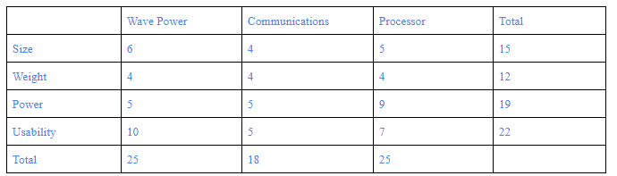

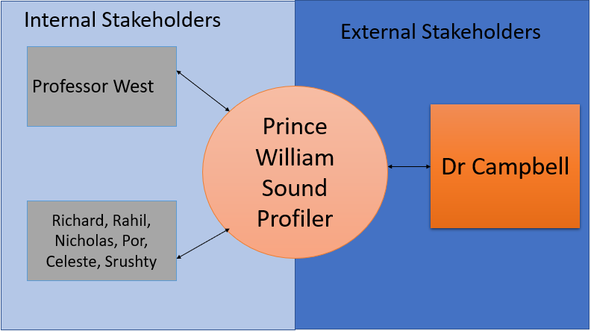

**Figure 2.** Stakeholder chart for Prince William Sound Profiler

# 3. Technical Specifications

**Table 2.** Target technical specifications of the system

|  |  |  |
| --- | --- | --- |
| Specification | Min | Max |
| Target Functional Temperature | -2 C | 30 C |
| Target Power Generation | 3 W | 10 W |
| Target Communications Range | 0 m | 2 km |
| Communications Frequency | 860 MHz | 915 MHz |

The proposed technical specifications can be seen in Table 2 above. These specifications are subject to change as development of the product progresses. However, they will serve as ideal guidelines in order to encourage an organized development process. The functional temperature specification relates to the temperature that the entire system should be able to operate at, which is relative to the location of the Prince William Sound. The power generation specification refers to the power being produced by the proposed generator. With the proposed generator, the team theoretically would want to produce a minimum of 3W worth of energy to the battery to charge. On the low end of power supply we would just be supplying the RPi doing processing and the LoRa radio, on the high end is powering all sensors. Next, the communications range is the range that the profiler should be able to transmit data. Finally, the communications frequency specification is determined by the operation frequency of the LoRa radio bonnet which can range between 860 MHz and 915 MHz depending on the specific unit we receive.

# 4. Design Approach and Details

## 4.1 Power Generation Technical Details

### **4.1.1 Design Concept Ideation**

**Power/Energy Source for the PWS Autonomous Moored Profiler**

Point absorbers are floating structures that have a small horizontal dimension compared to their vertical dimension and utilize the wave action at a single point. Most designs for point absorbers resemble a typical buoy, at least from the surface. Generally one end of the absorber is fixed (or relatively fixed compared to the water surface) while the other moves in a vertical motion, the resulting reciprocating action is used to pump a fluid or drive a linear generator, which in turn can provide usable power. Point absorbers are one of the most common design types in the industry today [15].

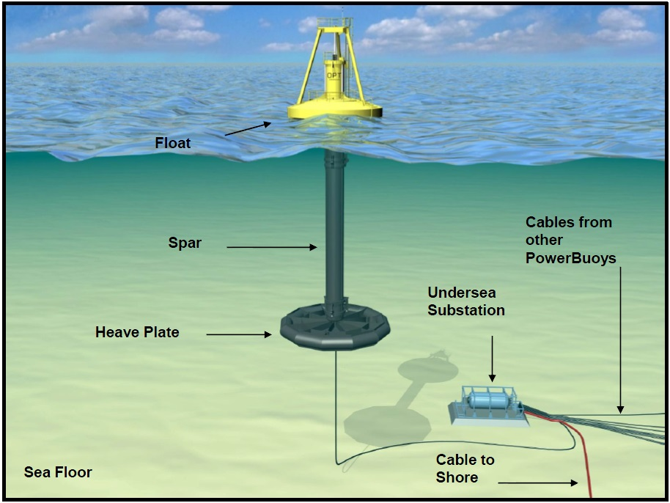

**Figure 3.** Example of the point absorber [15]

A point absorber utilizes the motion of the surface waves to generate electricity. A point absorber will experience many external loads, (such as winds, waves, and currents) and internal loads (such as shifting masses in the device). It should be stable enough to be able to withstand these loads and prevent itself from turning over [6].

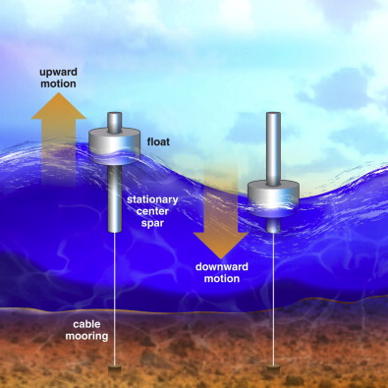

**Figure 4.** Example of the point absorber [20]

### **4.1.2 Design Concept Constraints**

**Power/Energy Source for the PWS Autonomous Moored Profiler**

Using a point absorber as a method to generate power/energy to the PWS Autonomous Moored Profiler could have the following constraints:

* The power from the point absorber is dependent upon wave motion.
* Any small garbage, object or animal can be struck between the spar and float, which could allow the point absorber to be unable to generate power or unable to provide enough power for the profiler.

### **4.1.3 Design Concept Alternatives**

There are many alternative methods that the PWS Autonomous Moored Profiler can be recharged with other than using a point absorber for a wave power converter. Besides the point absorber, we can also employ other wave power converters, such as attenuators and submerged pressure differentials.

**Attenuators or Linear Absorbers**

Attenuators, or linear absorbers, are wave energy converters that are oriented parallel to the direction of wave travel. The majority of the time they’re modular in design and rely on the flexing of joints to generate power. Their design looks similar to two barges that are linked together, or in some cases, a sea snake. These devices try to capitalize on several different translations of motion; such as surge, sway, and heave as examples [15]. These converters are placed parallel to the force and direction of a wave. The motion of the device from the crest and trough of the wave exerts force on a turbine that then feeds energy into the grid [5].

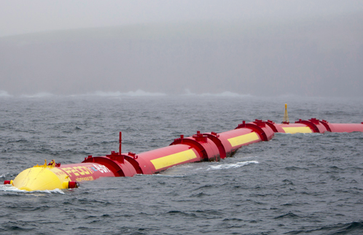

**Figure 5.** Example of attenuator

**Submerged Pressure Differential**

Submerged pressure differential comes in two different types. In one type, the device rests on or near the seafloor and relies on pressure fluctuations as a wave passes overhead to flex a pliable material such as an air bladder and squeeze a fluid to drive a turbine or some other power take-off unit. The other type is similar to a point absorber, but the submerged, like that shown below. In this type, a buoyant, submerged float is actuated by passing waves and this reciprocating motion is converted to energy with a linear generator [15]. The reason the team did not pursue this topic was because this model would require the prototype to be in shallow water and rest on the seafloor.

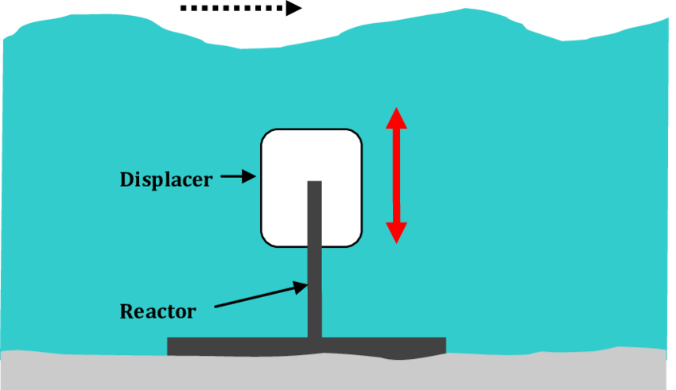

**Figure 6.** Example of submerged Pressure Differential

Other than using wave energy, the PWS Autonomous Moored Profiler can be recharged with different renewable energy methods, such as solar energy and wind energy, which we have also considered as well.

**Solar Energy**

Solar energy is not our primary choice for generating energy because there are many limitations and disadvantages compared to the wave power converters. For example, solar energy is very weather and time dependent. Therefore, energy cannot be generated at night or when there is a snow or rain or storm. Specifically, the intensity of daylight is poor in Prince William Sound. In addition, a solar panel degrades over time; therefore, a solar panel can usually be used between 20-25 years before the panel has lost all of its efficiency [2]. The efficiency of a solar cell will degrade around 5-10% each year [8]. Furthermore, the solar panels can be easily damaged in the environment proposed. However, solar energy could be implemented in conjunction with wave energy in a future design to generate more power.

**Wind Energy**

Wind energy is also not our primary choice because it would require significant modifications to the nearby buoy, which is not in the scope of this project. A large turbine could also lead the buoy to be less stable. Wind energy is also less consistent than wave energy [8]. However, wind energy could be implemented in conjunction with wave energy to produce more power in the future.

### **4.1.4 Design Concept Tradeoffs**

**Table 3.** Point Absorber Pros and Cons

|  |  |  |
| --- | --- | --- |
| **Point Absorber vs. Attenuator and Submerged Pressure Differential** | | |
| Pros | 1. Design is much simpler to implement 2. Considerably easier to use and cheaper to make 3. Being a standalone device or an added device to the current profiler | |
| Cons | 1. Required a lot of spaces in vertical plane (from the surface to seabed) 2. Structure could be eroded and degraded by saltiness of seawater; therefore, damaging the system | |
| **Wave Power vs. Solar and Wind Energy** | | |
| Pros | 1. Relatively more safe to be installed in the ocean 2. Waves are hardly interrupted and almost always in motion; therefore, more reliable 3. Potential amount of power that comes in waves are huge (roughly 30-40 kW for every meter) | |
| Cons | 1. Harder to maintain as wave energy converter is larger in scale 2. Due to the scale of the wave energy converter, engineers would potentially have to disassemble the point absorber by pieces to do maintenance 3. Costs of wave power are generally very high | |

Based on the pros and cons listed in Table 1, the point absorber wave power generator has a more feasible design to manufacture and experiment upon with the given constraints surrounding this project. With the skillset of the group and resources at hand, the point absorber seems to have more of an advantage compared to the other alternatives as it will not require us to innovate pre-existing systems currently in place; therefore, it'll theoretically be an add-on that can easily be deployed near the current location of the profiler.

### **4.1.5 Final Design for Power/Energy Generation**

After carefully reviewing all the options for this proposed project, the team has decided to develop according to the point absorber method. Our first choice was the wave attenuator; however, based on the initial design, we concluded that it would not generate enough power for the situation at hand. As a result, we chose the point absorber as it will be relatively easier to scale down and will generate more power than the alternatives.

Our current point absorber design consists of magnets stacked within a 1” diameter PVC pipe and coils inside a float surrounding it which will move up and down based on the waves to generate power. There are stationary stoppers on each end of the PVC pipe to limit the range of motion of the float. In addition, it will be tethered to a buoy on top and be moored to the seabed to keep it in position. Lastly, there will also be a rectifying circuit between the point absorber and battery connected to the profiler via a sub-sea cable for a constant charge.

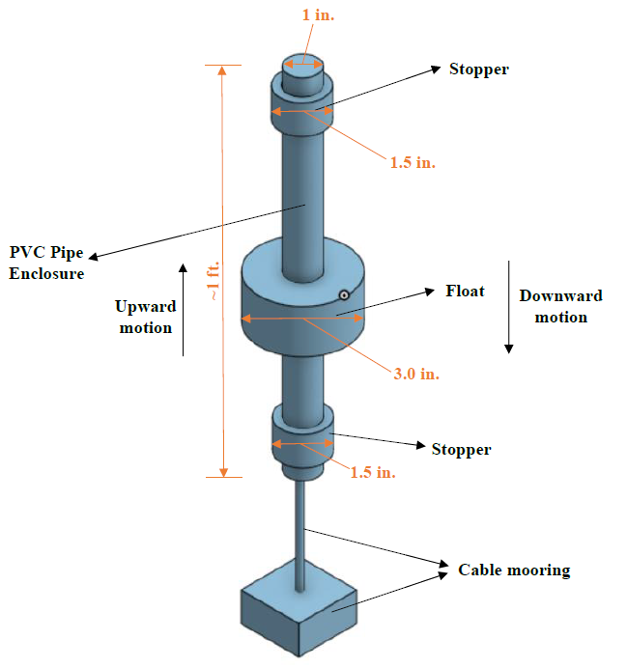

**Figure 7.** Initial CAD sketch of proposed point absorber.

## 4.2 Computing Aspects

### **4.2.1 Communication Module**

Communication is not the main focus of this project, but is an aspect that is important to be present in the final product based on the needs of our customer. As a result, we have looked for an easily accessible option that can be rapidly implemented to our current design. The component we have decided to employ is the Adafruit LoRa Radio Bonnet with OLED - RFM95W @ 915MHz - RadioFruit. The device adds a LoRa / LoRaWAN radio to the RPi. It also includes a 128x32 OLED display to ease debugging which is connected to the device via the I2C communication bus. The device allows for 868MHz to 915MHz transmission/reception and can be tuned dynamically. Its transmission range can be greatly expanded with simple antennas, so this is a part that would have to be upgraded in a future deployment. With directional antennas it could transmit up to 20 kilometers. Another major reason we have decided to use the Adafruit LoRa Radio Bonnet is there are ready-to-go CircuitPython libraries to aid in software development for this device [17].

The Adafruit LoRa Radio Bonnet module has many constraints and could not be used as is for the final module for communication, but serves as a good example for a prototype. Some constraints include:

* By itself can only transmit 2 Km in line of sight
* Not as fast as WiFi or Bluetooth
* Does not maintain a link/pairing like WiFi or Bluetooth

### **4.2.2 Processor**

The Raspberry Pi 4 has been chosen for this project. We have considered other processors such as the ODROID, and other RPi models, but have ultimately decided to use the RPi 4 because of our past experience with RPi and the wealth of publicly accessible knowledge and examples that exist for the RPi platform. The upgraded processor on the RPi 4 was attractive for this application due to the machine learning that would be integrated in the future as well as the number of serial connections available.

**Table 4.** RPi Tradeoffs

|  |  |  |  |  |  |
| --- | --- | --- | --- | --- | --- |
|  | **RPi 4** [7][18] | **RPi 3 B+** [7][18] | **RPi 3** [7][18] | **Odroid C4** [9] | **BeagleBone Black** [4][18] |
| Power at idle | 540 mA  (2.7 W) | 350 mA  (1.9 W) | 260 mA  (1.4 W) | 1.9 W | 290 mA (1.45 W) |
| 400% CPU load | 1280 mA  (6.4 W) | 980 mA  (5.1 W) | 730 mA  (3.7 W) | 3.1-3.3 W | - |
| Clock Speed | 1.5GHz | 1.4GHz | 1.4GHz | 2.0 GHz | 1.0 GHz |
| RAM | 1GB/2GB/4GB | 1GB | 1GB | 4GB | 512 MB |
| Serial Connections | 6 | 2 | 2 | 2 | 5 |

Overall, based on Table 4 above, the ODROID C4 has a higher clock speed and more RAM by default, but no one in the group is familiar with the system and the learning curve, and possibly lead time, could be significant. The other advantage of using a RPi denomination is that both the senior design lab and The Hive have Raspberry Pi 3, 3B+, and 4 in stock so we can begin development immediately. The Hive also has BeagleBone Black’s, but the set up is more difficult and the performance is lower. Additionally in past courses such as ECE 4180 embedded development has been performed on the RPi, so we know this kind of development is possible. Finally, for future sensor integration the RPi lends itself better to sensor integration because it has the highest number of serial connections available, plus USB connectors that could be integrated with RS232 to USB connections. The chart in the appendix shows the current sensors and their communication protocols, showing that seven serial connections are needed, which is possible on the RPi 4 through the use of hats and USB connections.

### **4.2.3 Compass**

A digital compass is a sensor that provides information about azimuth, pitch angle, roll angle, temperature, depth, magnetic vector length, acceleration vector length, 3 axis acceleration readings, 2 axis Gyro Output, etc. (from pdf). The information that is outputted from the compass is in the form of sentences in four different formats at a fixed rate. This hex data will be sent to the Raspberry Pi over a serial interface. The data received on RPi will be parsed to obtain different parameters and values. That data will be stored in a ‘.txt’ file file. We plan to obtain the collected data from those files and show it on the user interface.

### **4.2.4 Battery Communication**

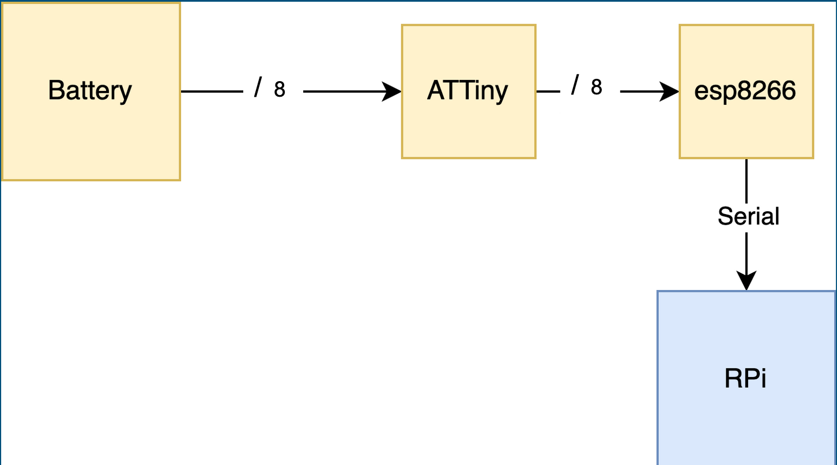

**Figure 8.** Block diagram of communication between battery and Raspberry Pi

The diyBMSv4 system made by Stuart Pittaway will be used for battery management and communication. It includes ATTiny boards for each battery cell which then report data such as temperature, voltage, and current to an ESP8266 microcontroller. The software/hardware for this system is included with the diyBMS system. The part we will be constructing is a serial bridge from the ESP8266 microcontroller to the RPi. The ESP8266 will dump data about each battery cell over the bridge each time a packet is received and the RPi will transmit this data over the LoRa radio when communication can be established.

A limitation associated with the diyBMS system is that the ESP8266’s main purpose in the diyBMS is to facilitate WiFi communication to its pre-built user interface, but for our application we are skipping over the WiFi communication and adding a direct line for serial communication to the RPi. A better way of doing this would be to switch out the ESP8266 for a more suitable microcontroller, or build the communication with the ATTiny’s into the RPi. This is not in the scope of the project this semester so this will be a future improvement on the system.

### **4.2.5 User Interface**

The current model of user interface is written in python and it connects Raspberry Pi to the user. The interface will be running on Raspberry Pi since it will be displaying the data obtained from the radio. The first model we created, displays different options of choosing cells which allows the user to see the data of particular cells they are interested in. In future, we plan to build a graph sensor data interface with python and matplotlib module that shows graphical data with various parameters such as temperature, voltage, power etc against time. We could also implement a GUI to show output of the sensor in real time where the graph will be updated in fixed time intervals.

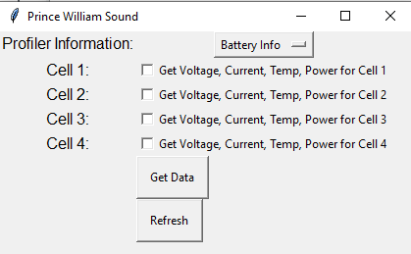

**Figure 9.** Current GUI example

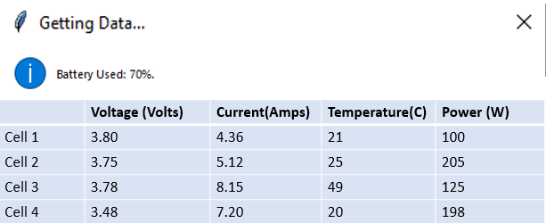

**Figure 10.** An example of current GUI in tabular form

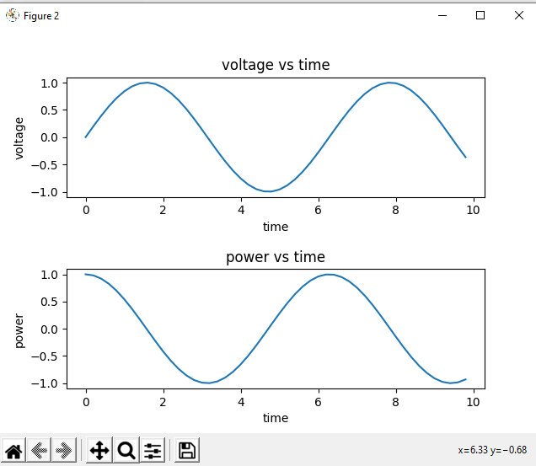

**Figure 11.** Graphical data from the cells

## 4.3 Engineering Analyses and Experiment

When we successfully waterproof the prototype wave power generator, testing will be accomplished using water tanks in Georgia Tech labs that will replicate the environment that the proposed point absorber will be in. The miniature point absorber will be placed into these water tanks, which machine-made or man-made waves will be created in order to produce the necessary waves to generate power within the point absorber that will be connected to an arbitrary device to measure the amount being produced. Based on these experimental measurements, changes will be made to the device accordingly to ensure proper design meets specifications.

As a contingency to not waterproofing the device, we will manually move the device to replicate waves and connect it to a device to measure the amount of power being generated. Again, based on these experimental measurements, we will make changes to the device.

### **4.4 Codes and Standards**

Relevant codes and standards include:

* LoRa, which short for long range, is a long range, low power wireless platform that is used widely in the Internet of Things applications [16]
* SPI, Serial Peripheral Interface, is the communication interface for the chosen communications module
* Serial (RS232) is the standard that will be used for communication with the battery pack along with many of the future sensors
* I2C, Inter-Integrated Circuit, is the communication bus used to show information on the LoRa radios’ display screens.

# 5. Schedule, Tasks, and Milestones:

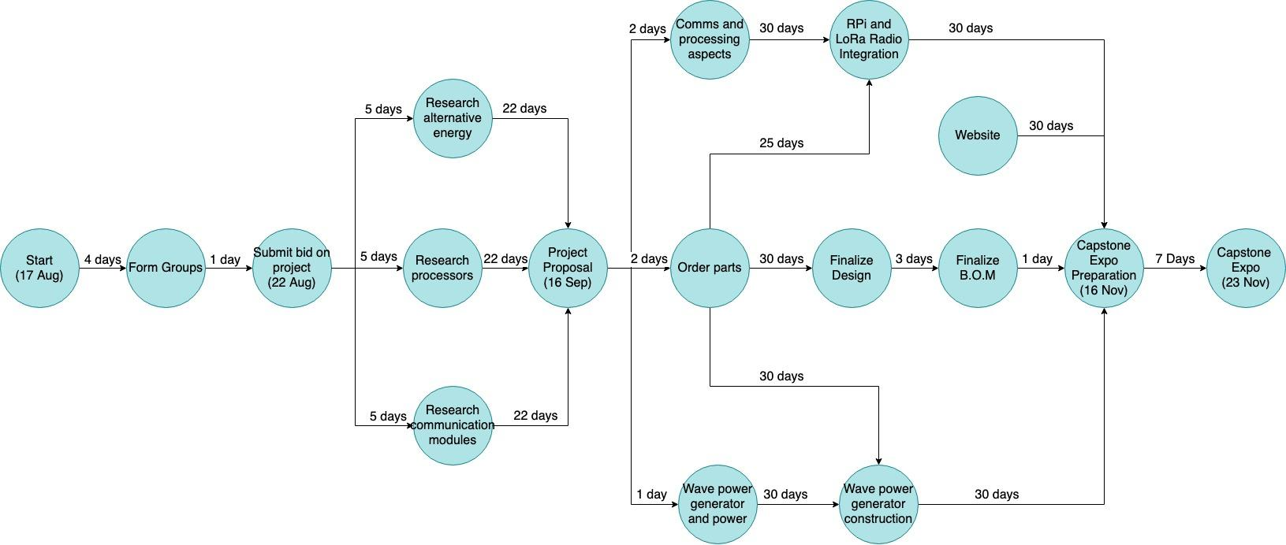

**Figure 12.** PERT Chart of the flow of the development process

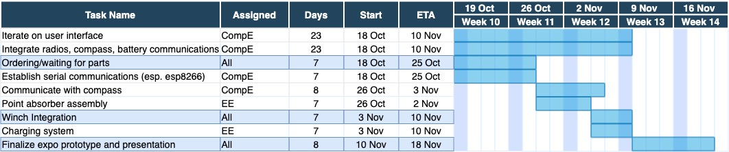

**Figure 13.** GANTT Chart with definitive dates during development

Based on our proposed schedule the probability that we will finish before the design expo is 90%. There is some risk associated with the wave power generation, but we believe we have allocated enough time for testing and development.

# 6. Project Demonstration

We will build the prototype proposed in this report and demonstrate its operation at the Capstone Design Expo. We will have the point absorber trickle charging the battery, which will provide data to the RPi through the diyBMS. The data supplied to the RPi will be relayed over the LoRa radios and be displayed in the user interface to show the voltage of the battery cells increasing. The compass will also be connected and information about the heading angle, temperature, and depth will be relayed to the user interface remotely through the LoRa radios. We will also have the winch connected to show the device reel and unreel.

Ideally the power generation will occur while submerged in a water tank within a lab environment with a line running to the battery and other components on a lab bech, but in the event that we do not accomplish the mechanical aspects of waterproofing we will simulate the waves through manually moving the components.

We have already demonstrated reading serial data through the Raspberry Pi and relaying it, through the LoRa radios, from one pi to the other. We are confident we will be able to add the other aspects of the demonstration before the demo.

# 7. Marketing and Cost Analysis

**Power/Energy Source for the PWS Autonomous Moored Profiler**

In this project, we are planning to design our own point absorber in order to prove the concept of being able to charge the battery on the PWS Autonomous Moored Profiler on a small scale using smaller parameters that will be able to manipulate in future uses with the actual project. With that being said, there are several existing ideas and products that work the same as the point absorber the team is proposing.

The most popular existing product of the point absorber is the AquaBuOY, manufactured by AquaEnergy Development UK Limited (a subsidiary of Finavera Renewables) [19]. AquaBuOY is a freely floating heaving point absorber, reacting against a submersed reaction tube (mass of water). The reaction mass is moving a piston assembly which drives a steel reinforced elastomeric water pump (hose pump). The hose pump pushes water on a high pressure level. An accumulator is used to smooth the power output and the pressure head is then discharged onto an impulse turbine to generate electricity. Grid synchronization is achieved using a variable speed drive and step-up transformer to a suitable voltage level. The manufacturer of AquaBuOY stated that a device is able to produce 250 kW of energy, with an associated capacity factor of about 12% (assuming a 25kW/m wave climate). It is predicted that a capacity factor of around 40% could provide a near optimal economic value of electrical energy for this type of a device [21].

**Figure 14.** AquaBuOY by AquaEnergy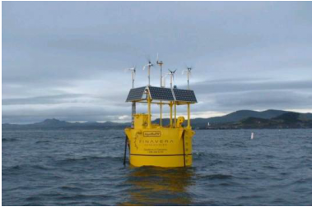

Due to the fact that the profiler requires very low energy, 1.5 kWh, to operate, our designed project will only need to generate a smaller amount of the energy. Therefore, our design of the point absorber will be much smaller in size than the products from the current market.

**Communication Module and Processor**

In future versions of this product a higher range version of a LoRa radio would need to be implemented, currently it requires line of sight which will not be possible in PWS. Additionally, a more specialized processor for this application will need to be implemented.

**Cost Analysis**

**Table 5.** Cost for each part

|  |  |  |  |
| --- | --- | --- | --- |
| **Topics** | **Materials** | **Quality** | **Total Price** |
| Power Generator | Temflex 3/4 in. x 60 ft. 1700 Electrical Tape Black | 1 | $1.78 |
|  | Rare Earth 3/4 in. x 1/4 in. Disc Magnet (4-Pack) | 12 | $190.42 |
| Battery Communication | Raspberry Pi 4 15W Power Supply | 1 | $8.47 |
| Radio Communication | Adafruit LoRa Radio Bonnet with OLED | 2 | $80.22 |
|  |  | Total | $280.89 |

The total budget of this project is $700. Based on our prices, we are under budget with a total cost of $280.89.

# 8. Current Status

**Power/Energy Source for the PWS Autonomous Moored Profiler**

* Find the best method as the power/energy source for the PWS Autonomous Moored Profiler: 100% Complete
* Have the final product
  + Design our own point absorber: 100%
  + Find and order the parts for the point absorber: 100%
  + Build the point absorber: 40%
  + Testing the product: 0%

**Communication Module and Processor**

* Find the module we will use as a black box communication box: 100%
* Decide on a processor that will fit the needs of the design: 100%
* Understand how to integrate integrate the LoRa radio with the RPi: 100%

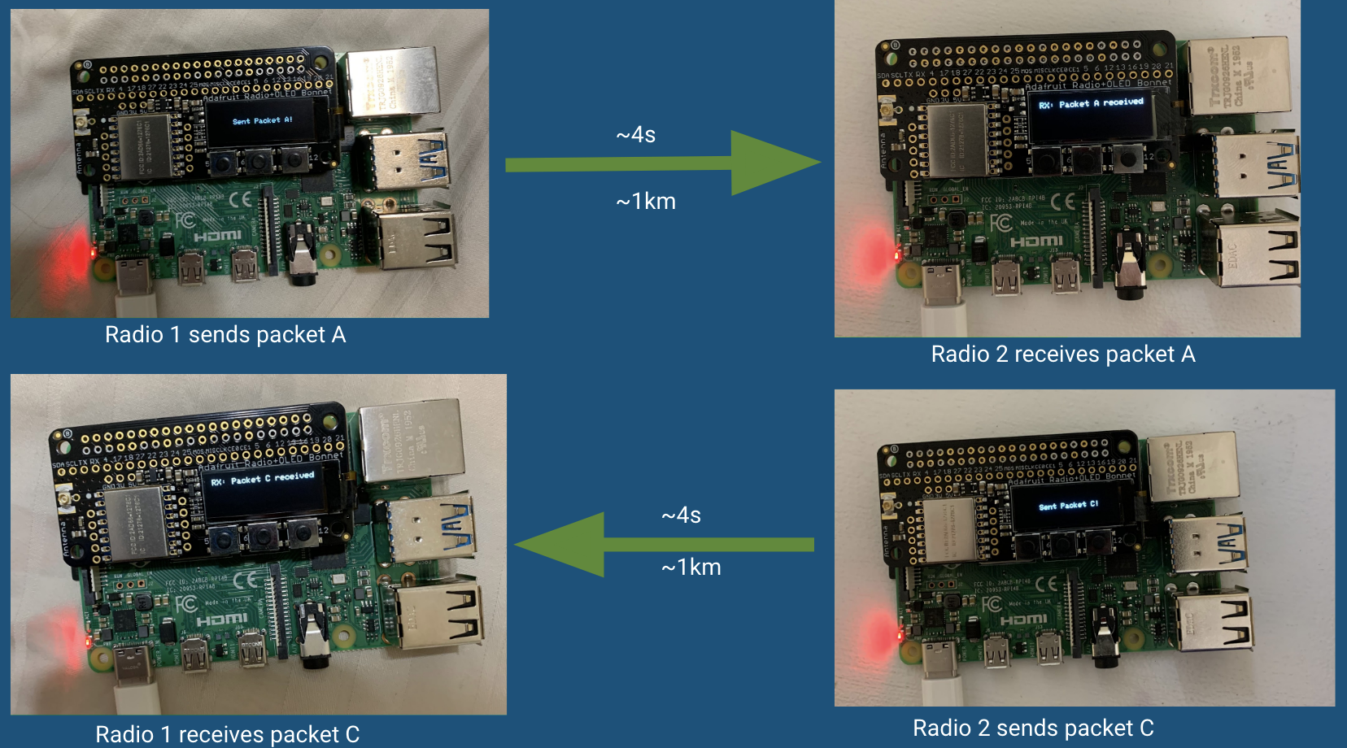

**Figure 15.** Successfully sent packets between radios 1 km apart

* Integrate the LoRa radio with the RPi: 100%

**Communicate Between diyBMS and Processor**

* Establish serial communication: 100%
* Parse data: 10%

**Communicate Between Compass and Processor**

* Establish serial communication: 100%

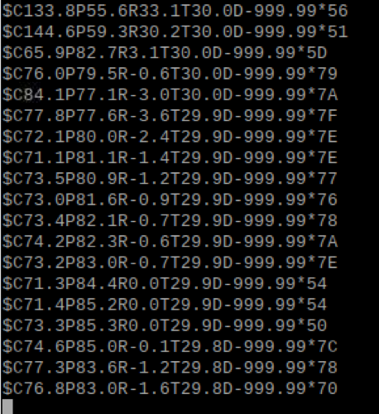

**Figure 16.** Compass sentences being captured and output on the RPi

* Parse data: 10%

**User Interface**

* Get the data from cells in a graphical manner: 20%

**Winch Integration**

* Toggle reel and unreel through commanding on RPi: 0%

# 9. Future Improvements

Improvements for future groups include upgrades to the communication module to either design antennas for increasing the range of the LoRa radio or switching them out entirely for a more application specific module. Additionally, the RPi could be switched out for a more application specific microprocessor like the ODROID C4.

Furthermore, sensors to perform the function of the current profiler could be added. Currently we have an Ocean Server Digital Compass integrated, but in the future the plankton camera and other water profiling sensors should be integrated.

In terms of increasing the power generated from the point absorber, we can increase the physical size of the device which would mean more or larger magnets and a larger range of motion for the float containing the coils. We can also increase the number of coil windings used - if not replace it entirely with industry sized stators. If that is not enough, we can have multiple bigger scaled point absorbers, on the same connection, working together to generate sufficient power.

# 10. Leadership Roles

Our currently defined leadership roles are

* Group Leader: Celeste Smith
  + Coordinate meetings and serve as spokesperson
* Webmaster: Nicholas Nguyen
  + Have the key to the website and be in charge of deploying information to the website
* Documentation Coordinator: Srushty Changela
  + In charge of making sure we are taking and maintaining the necessary documentation
* Expo Coordinator: Rahil Ajani
  + Coordinate everything for our group to present at the expo
* Financial manager: Richard Nguyen
  + In charge of reimbursements and keeping track of costs
* Power Lead: Kombundit Chitranuwatkul
  + Lead on the electrical engineering/power engineering side of the project

# 11. References

1. “About - Prince William Sound Science Center.” Prince William Sound Science Center. <https://pwssc.org/about/> (accessed September 14 2020).
2. “About Solar Energy | SEIA.” Solar Energy Industries Association. <https://www.seia.org/initiatives/about-solar-energy> (accessed September 13, 2020).
3. “Attenuator - Analysis of Cost Reduction Opportunities in the Wave Energy Industry.” University of Strathclyde. <http://www.esru.strath.ac.uk/EandE/Web_sites/14-15/Wave_Energy/attenuator.html> (accessed September 14, 2020).
4. “BeagleBone Black.” Beagle Board. https://beagleboard.org/black. (accessed September 15, 2020).
5. “Energy And The Environment-A Coastal Perspective - Attenuators.” Coastal Energy And Environment.web.unc.edu. [http://coastalenergyandenvironment.web.unc.edu/ocean-energy-generating-technologies/wave-energy/the-pelamis-wave-energyconverter/](http://coastalenergyandenvironment.web.unc.edu/ocean-energy-generating-technologies/wave-energy/the-pelamis-wave-energy-converter/) (accessed September 13 2020).
6. Faizal, M., Ahmed, M. and Lee, Y., “A Design Outline for Floating Point Absorber Wave Energy Converters,” *Advances in Mechanical Engineering*, vol. 6, Feb. 15, <https://journals.sagepub.com/doi/10.1155/2014/846097> (accessed September 13, 2020).
7. J. Geerling. “Power Consumption Benchmarks.” Raspberry Pi Dramble. <https://www.pidramble.com/wiki/benchmarks/power-consumption> (accessed September 13, 2020).
8. Talaat, M., Farahat, M.A. and Elkholy, M.H., “Renewable power integration: Experimental and simulation study to investigate the ability of integrating wave, solar and wind energies,” *ScienceDirect*, vol. 170, pp. 668-682, Mar. 2019, <http://www.sciencedirect.com/science/article/pii/S0360544218325453>.
9. “ODROID-C4.” ODROID. <https://www.hardkernel.com/shop/odroid-c4/> (accessed September 15, 2020).
10. “Prince William Sound Recent Marine Data” NDBC. <https://www.ndbc.noaa.gov/maps/Alaska_inset.shtml> (accessed September 14, 2020).
11. R. Campbell, “A Profiling Observatory for High Resolution Oceanographic, Biogeochemical, and Plankton Observations in Prince William Sound.“ *Prince William Sound Science Center.* [Online]. Available: <https://drive.google.com/file/d/1uin5A8rl6_Gcp6-w-3mS5BZkiQ6HwGLV/view> (accessed September 14, 2020).
12. “The Basics of Wind Energy | AWEA.” American Wind Energy Association. <https://www.awea.org/wind-101/basics-of-wind-energy> (accessed September 13, 2020).
13. “The Prince William Sound Plankton Camera: a profiling in situ observatory of plankton and particulates.” ICES Journal of Marine Science. <https://drive.google.com/file/d/1-PuFgZ_EeXKMH_uZcOuvVcdq-dWTjals/view> (accessed September 14, 2020).
14. “Thetis Profiler.” Sea-Bird Scientific. <https://www.seabird.com/systems/thetis-profiler/family?productCategoryId=54627869948> (accessed September 13, 2020).
15. “Wave Energy Converters - The Liquid Grid.” The Liquid Grid. <https://theliquidgrid.com/marine-clean-technology/wave-energy-converters/> (Accessed 13 September 2020).
16. “What is LoRa®?.” Semtech. <https://www.semtech.com/lora/what-is-lora> (accessed September 13, 2020).
17. “Adafruit LoRa Radio Bonnet with OLED - RFM95W @ 915MHz.” Adafruit. <https://www.adafruit.com/product/4074> (accessed September 13, 2020).
18. “UART Configuration.” UART Configuration - Raspberry Pi Documentation. [www.raspberrypi.org/documentation/configuration/uart.md](http://www.raspberrypi.org/documentation/configuration/uart.md) (accessed September 16, 2020).
19. Lemos, E., Haraczy, N. and Shah, A., “Estimating the Generating Efficiency of the AquaBuOY 2.0,” *ResearchGate,* October 2018, <https://www.researchgate.net/publication/328281087_Estimating_the_Generating_Efficiency_of_the_AquaBuOY_20>
20. Li, Y, and Yu, Y., “A synthesis of numerical methods for modeling wave energy converter-point absorbers,” *ScienceDirect*, vol. 16, pp. 4352-4364, August 2012, <https://www.sciencedirect.com/science/article/abs/pii/S1364032111005351>
21. “Point Absorber - Analysis of Cost Reduction Opportunities in the Wave Energy Industry.” University of Strathclyde. <http://www.esru.strath.ac.uk/EandE/Web_sites/14-15/Wave_Energy/point-absorber.html> (accessed October 26, 2020).

# Appendix

|  |  |  |
| --- | --- | --- |
| Instrument | Link | Communication Protocol |
| Seabird FASTCAT | <https://www.seabird.com/asset-get.download.jsa?id=54627862103> | RS-232 |
| RBR brevio | <https://rbr-global.com/products/standard-loggers/rbrbrevio> | RS-232 |
| Seabird Eco FLNTU | <https://www.seabird.com/combination-sensors/eco-flntu/family?productCategoryId=54758054352> | RS-232 |
| Seabird SBE 63 | <https://www.seabird.com/oxygen-sensors/sbe-63-optical-dissolved-oxygen-sensor/family?productCategoryId=54627869933> | RS-232 |
| Aanderaa Optode | <https://www.aanderaa.com/productsdetail.php?Oxygen-Optodes-2> | CANBus and RS-232 |
| Seabird SUNA | <https://www.seabird.com/nutrient-sensors/suna-v2-nitrate-sensor/family-downloads?productCategoryId=54627869922> | Serial |
| Plankton cam |  | Serial |