**Semi-Autonomous Drone Surveillance**

ECE4873 Senior Design Project

Drone Buddy

Dr. Jennifer Hasler

Sriharsha Singam, CmpE, [harshasingam3@gatech.edu](mailto:harshasingam3@gatech.edu)

George Germanakos, CmpE, [ggermanakos3@gatech.edu](mailto:ggermanakos3@gatech.edu)

Jerrin Kakkanatt, EE, [kakkanattj@gatech.edu](mailto:kakkanattj@gatech.edu)

Zach Mathews, EE, [zmathews3@gatech.edu](mailto:zmathews3@gatech.edu)

Submitted

December 7, 2020

**Executive Summary**

Drone Buddy is a semi-autonomous surveillance drone designed to provide a sense of security to commuters-by-foot. The drone follows commuters and streams live surveillance footage to remote servers. The system is composed of a smartphone app for calling the drone, a remote server for capturing streaming data, and an unmanned aircraft equipped with a camera for image capture and a single board computer (Raspberry Pi) for communicating with the central server. Technical challenges included fitting all equipment on the drone chassis and achieving sufficient flight time to follow a commuter to their destination. Current price for the system is in the range of $1200 to $1300. The drone can achieve a flight time of 30 minutes and a flight speed of 35 kmph. A primary proof of concept for this idea is the commercially available line of drones built by the company DJI [1]. The next step would be to work on the active crime detection system, since that aspect of the drone was not implemented due to time constraints and covid19. The use of the commuter-requestable surveillance drone is expected to deter larceny, theft, sexual assault, and hate crimes by a substantial degree in high-foot traffic areas such as college campuses where students carrying expensive electronics are prime targets for muggings. The Georgia Tech Police Department recorded 252 acts of theft in 2019 [3].

**Table of Contents**

**Executive Summary** ii

1. **Introduction** 1
   1. Objective 1
   2. Motivation 1
   3. Background 2
2. **Project Description and Goals** 2
3. **Technical Specification** 3
4. **Design Approach and Details**
   1. Design Concept Ideation, Constraints, Alternatives, and Tradeoffs 4
   2. Design Technologies 5
   3. Engineering Analyses and Experiment 6
   4. Codes and Standards 6
5. **Schedule, Tasks, and Milestones** 7
6. **Final Project Demonstration** 7
7. **Marketing and Cost Analysis** 8
   1. Marketing Analysis 8
   2. Cost Analysis 8
8. **Leadership Roles**  9
9. **References** 10

**Appendix A** 11

**Appendix B** 12

**Appendix C** 13

**Appendix D**  14

**Semi-Autonomous Drone Surveillance**

**1. Introduction**

Drone Buddy is a semi-autonomous drone that through the internet can be controlled remotely by security officials and accessed by common students. The drone provides additional surveillance with live feed from its video camera.

**1.1 Objective**

The objective of Drone Buddy is to provide fast and accessible additional surveillance to students on college campuses. The drone can be summoned through a smartphone app, and will navigate itself to the students using GPS location. The drone has the capability to follow the student back to their home. The drone can also be controlled remotely by security officials for quicker response times by providing them a live video feed.

**1.2 Motivation**

Motivation for designing a campus surveillance drone came from wanting to provide a safer environment for college students. With the introduction of closed circuit television surveillance, crime is reduced by 13%. Having an unmanned air vehicle following students at night with constant surveillance provides additional safety.

**1.3 Background**

**Unmanned Aerial Vehicle Use In Security**

Security companies have recently started using drones to monitor for potential risks in large public gatherings. However, Drone Buddy is different as it will be required to respond to smaller, more individual situations. This will require a greater quantity of drones per institution in case of multiple requests. The drone will fly to the student and follow them for the duration of their commute and then return to its charging station. This drone will have a flight time of around 30 minutes. This is quite similar to most commercial drones, since they only have around 30 minutes of flight time [1].

**2. Project Description, Customer Requirements, and Goals**

Drone Buddy’s goal is to build an autonomous drone to aid in passive and active safety monitoring and prevention. This will require two advanced prototypes of the drone that should be able to fly by themselves, take instructions from the onboard computer regarding where to go and what to do, and sense if danger is present in the vicinity

Unfortunately, due to time constraints as well as the ongoing pandemic the main requirements fulfilled was the passive crime prevention as well as live camera feed. This includes only building one of the drone prototypes.

Here are the constraints that have been fulfilled successfully:

Drone:

* Design Constraints (look at Appendix B):
  + ~~Minimum of 1 hour~~ 30 minute battery life.
  + ~~High resolution~~ camera.
  + ~~Weather Resistant.~~
  + Privacy Protective Design -- in Software and Hardware.
* Passive Crime Prevention:
  + Follow pedestrians upon request on a Mobile App.
  + Act as a safeguard with lights and speakers.
* ~~Active Crime Dissuasion:~~
  + ~~Respond by calling other drones to the location.~~
  + ~~Once there start dissuasion methods through loud noises and flashing lights.~~
  + ~~Call the police to that location.~~

Mobile App:

* Call the closest drone by:
  + Sending messages and GPS information to the cloud.
  + Cloud computes to find the closest available and charged drone.
  + Send drone coordinates.
  + Drone and App link up.

1. **Technical Specifications**

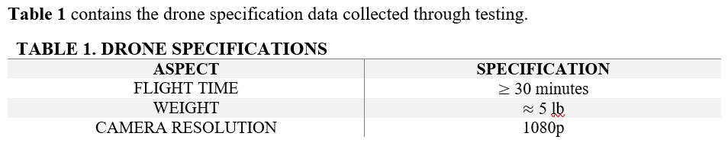

1. **Design Approach and Details**
   1. **Design Concept Ideation, Constraints, Alternatives, and Tradeoffs**

Drone Buddy envisions autonomous safety drones helping people feel and stay safe. The feature it needs to fulfill this goal includes active crime dissuasion and passive crime prevention.

The active crime dissuasion would mean the drone would need to sense danger in the surrounding regions and try to break up the conflict by the use of flashing red and blue lights and a loud speaker. When a crime is taking place, the perpetrator needs or would prefer less light and sound in the area to be able to conduct a stealthy crime. If this does not stop the crime or if it does, the drone along with 2 or 3 other drones will follow all potential perpetrators and victims. This will allow police officers to identify all people involved and to catch the perpetrator and help the victim very quickly. Unfortunately this feature was not included in the final demonstration due to time constraints as well as the ongoing pandemic.

The passive crime prevention involves the drone being called upon by a pedestrian. The drone finds and follows the pedestrian until their destination. This would prevent a couple of potential future crimes involving the pedestrian because it is less likely for someone to commit a crime when there is a drone watching their every move.

The core design features (passive crime prevention) and their cost can be seen in Appendix B.

* 1. **Design Technologies**

The primary technologies that have been used in the drone are a Lux F7 Flight Controller, Flutter SDK for Mobile App development used with AWS cloud servers, Betaflight Flight Controller Firmware and Configurator, OpenCV, and a USB LTE dongle.

* + 1. **Lumenier LUX F7 Ultimate Flight Controller (Dual Gyros)**

This flight controller was chosen for the cheap cost and high availability. This was necessary since we needed to buy multiple flight controllers for the team due to covid19. The flight controller features many sensors on board to help with flight stabilization and also contains an ARM microcontroller that is used for flight control.

* + 1. **Flutter SDK**

Flutter has been used for developing the app. It is a cross-platform UI toolkit designed to ease the production of high-quality mobile phone experiences [7]. It enabled the team to write a single app and deploy across both major mobile operating systems: Android and iOS.

* + 1. **Betaflight Firmware and Configurator**

Betaflight is an open source repository on GitHub that allowed us to have a ready-made flight controller firmware to flash. The repository was forked and edits were made to the GPS data transfer to allow the flight controller to take GPS coordinates from the users phone.

Betaflight Configurator is another open source repository that was used to communicate with the firmware and to make changes to how the drone operated.

* + 1. **AWS Cloud**

AWS cloud servers enabled the users mobile phones to communicate with the drones. It also takes care of drone assignment to users as well as stores and streams all the video footage taken by the drone. Using AWS’s API Gateway, a seamless WebSocket interface was built throughout all devices in order to keep up constant communication of GPS data.

* + 1. **OpenCV**

The OpenCV library implements algorithms for detecting motion in images and the ability to detect faces using Haar cascades. Such technologies will enable the drone to make the most of its camera by focusing on subjects. The library is mature and released under a permissive BSD license making it a primary candidate for use. OpenCV’s capabilities was not fully implemented due to time constraints.

* + 1. **USB LTE Dongle**

ZTE USB LTE dongle allowed the drone to gain access to a constant LTE connection. This was required for the drone to get GPS updates from the user through AWS as well as to send streaming footage back to AWS.

* 1. **Incomplete Design Aspects**

The active dissuasion methods have not been fully implemented due to time constraints.

* 1. **Engineering Analyses and Experiment**
     1. **GPS Latency**

A GPS latency test was conducted to find out if using AWS’s WebSocket interface was fast enough to send accurate GPS data to the drone. The test concluded with the team agreeing that the AWS WebSocket interface was a viable option. Appendix D has a copy of the test results.

* 1. **Codes and Standards**

The FAA Reauthorization Act of 2018 gives the Federal Aviation Administration power to establish guidelines governing the use of national airspace [2]. Subtitle B lists the statutes regarding the use of unmanned aerial vehicles in public, educational, and recreational capacities.

In section 346, the act explicitly grants the Secretary of Transportation the power to issue a certificate of waiver or certificate of authorization for use of unmanned aircraft systems by government agencies. Several requirements must be met to permit use by a public safety agency including that the aircraft [2]:

1. weigh no more than 4.4 pounds
2. be flown less than 400 feet above ground
3. be operated only during daylight conditions
4. be operated solely within class G airspace at least 5 miles from any location with aviation activities

If the semi-autonomous surveillance drone, Drone Buddy, is to be used in a public safety capacity it must meet these requirements and undergo certification.

During the development, the drone was operated under the statutes governing the use of unmanned aircraft for recreational or educational purposes. The rules for recreational use are set forth in section 349. Those include that the aircraft must [2]:

1. be flown within visual line of sight and
2. no more than 400 feet above ground and
3. be registered and marked which requires passing an aeronautical knowledge and safety test.

The rules for educational use are set forth in section 350 [2].

1. **Schedule, Tasks, and Milestones**

A diagram identifying the critical path of project milestones is given in Appendix C. The timeline got greatly skewed because of the ongoing pandemic so the overall project goals had to be readjusted. The motion tracking algorithm development was pushed back to the least necessary task. The mobile app and backend system development took place in parallel with the drone chassis construction and flight controller firmware development. These 2 main tasks took a lot of time lasting the final day before the expo. The motion tracking development was not completed and was placed as potential future development.

1. **Project Demonstration**

Drone Buddy demonstrated a virtual version of the drone in action to the Georgia Tech Capstone Expo. Due to the pandemic and the nature of the presentation required, the final presentation featured a more theoretical view of the current state of the drone’s capabilities as well as the overall software platform and what the future could hold for it. A video compilation of the drone following a person as seen in the betaflight configurator, which was basically 2 icons on a gps map, gave an interesting view of the drone as would be seen by the Police Department once adopted.

1. **Marketing and Cost Analysis**
   1. **Marketing Analysis**

There are no products that fit the exact function of DroneBuddy that are currently on the market. Drone Buddy is aiming at an autonomous drone that is able to accompany someone in order to keep them relatively safe wherever they want to go and to sense nearby danger and track the perpetrator and the victim. These drones would not be controlled by someone 24/7 and will aid police in investigations and prevent future crimes by dissuading perpetrators. Most of the drones currently on the market are used for military purposes. There are companies though, who are building drones for the purpose of safety like DroneSense [5], but these companies are building drones that need someone to control them at all times which would remove any crime preventive nature of the drones. The autonomous nature of Drone Buddies safety drones would be a unique product.

* 1. **Cost Analysis**

The current cost of prototype parts themselves totals to $1284.52. This number is primarily based on the current list of parts required to build an autonomous safety drone. These parts would include normal drone parts such as motors, a drone chassis, a battery and charger, propellers, a flight control system, and varying screws and connectors necessary to build the drone itself. To add to these parts for Drone Buddies’ specific needs, the list also includes an LTE module, a camera, a radio transmitter and receiver, and a relatively powerful onboard computer to run all the machine learning programs necessary for the drone to be autonomous. These parts would be minimum needed parts to create a functioning Drone Buddy but are not be enough for the final product itself. On top of the cost of these parts, our team has spent at least a hundred hours each in the physical construction and the software development of the drone. The engineer’s salary will not be any different from most start-ups but the drone prototype costs are a bit high due to the drone needing to be autonomous and accompanying hardware and software to go with it (relatively powerful onboard computer). An accurate estimate of the price of the drone for sale is not able to be determined as the current state of the drone cannot be sold. Also, testing required would need to be more extensive and with multiple drone prototypes. Progress made was substantial, but not nearly enough to have a finished product.

1. **Leadership Roles**

Jerrin Kakkanatt was the head motor and chassis developer. Sriharsha Singam was the expo coordinator, group leader, and the head software developer. George Germanakos was the head data collector and analyzer. Zachary Mathews was the head controller, sensor developer, web master and the documentation coordinator.

1. **References**

[1] “Official Store for DJI Drones, Gimbals and Accessories (United States),” DJI store. [Online]. Available: https://store.dji.com/. [Accessed: 11-Apr-2020].

[2] Guthrie and Brett, “Text - H.R.302 - 115th Congress (2017-2018): FAA Reauthorization Act of 2018,” Congress.gov, 05-Oct-2018. [Online]. Available: https://www.congress.gov/bill/115th-congress/house-bill/302/text?q={"search":["FAA+Reauthorization"]}. [Accessed: 16-Apr-2020].

[3] “Georgia Institute of Technology Georgia Institute of Technology Police Department: Atlanta, GA,” Georgia Institute of Technology Police Department | Atlanta, GA. [Online]. Available: http://police.gatech.edu/crime-statistics. [Accessed: 17-Apr-2020].

[4] “DJI - The World Leader in Camera Drones/Quadcopters for Aerial Photography,” *DJI Official*. [Online]. Available: https://www.dji.com/phantom-4-pro-v2/specs. [Accessed: 17-Apr-2020].

[5] “Drone Software Platform for Public Safety,” *DroneSense*. [Online]. Available: https://www.dronesense.com/. [Accessed: 17-Apr-2020].

[6] “N3 Flight Controller - DJI,” DJI Official. [Online]. Available: https://www.dji.com/n3. [Accessed: 17-Apr-2020].

[7] “Beautiful native apps in record time,” *Flutter*. [Online]. Available: https://flutter.dev/. [Accessed: 17-Apr-2020].

**Appendix A - Gantt Chart**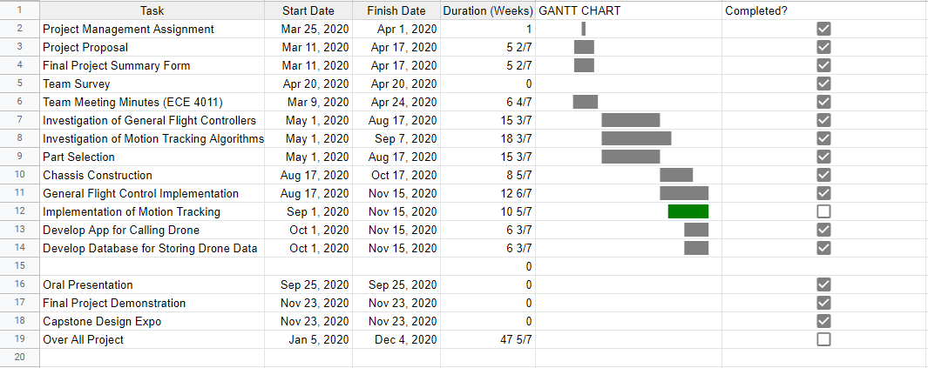

**Appendix B - Quality Function Deployment Diagram**

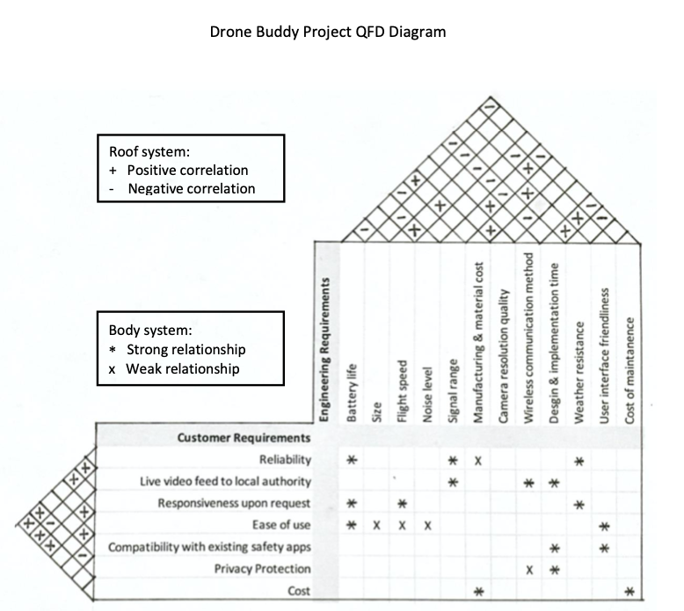

**Appendix C - CPM Diagram**

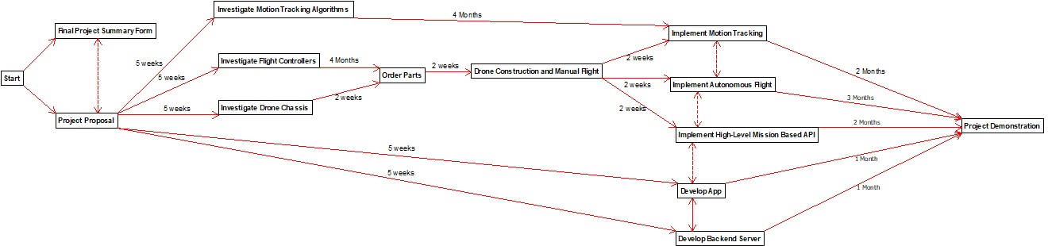

**Appendix D - GPS Latency Test Results**

