**Semi-Autonomous Drone Surveillance**

ECE4011 Senior Design Project

Drone Buddy

Dr. Jennifer Hasler

Sriharsha Singam, CmpE, [harshasingam3@gatech.edu](mailto:harshasingam3@gatech.edu)

George Germanakos, CmpE, [ggermanakos3@gatech.edu](mailto:ggermanakos3@gatech.edu)

Jerrin Kakkanatt, EE, [kakkanattj@gatech.edu](mailto:kakkanattj@gatech.edu)

Zach Mathews, EE, [zmathews3@gatech.edu](mailto:zmathews3@gatech.edu)

Submitted

April 17, 2020**Table of Contents**

**Executive Summary (5 pts)** ii

1. **Introduction (10 pts) George** 1
   1. Objective 1
   2. Motivation 1
   3. Background 2
2. **Project Description and Goals - Harsh (15 pts)** 2
3. **Technical Specification - Jerrin (15 pts)** 3
4. **Design Approach and Details (20 pts)**
   1. Design Concept Ideation, Constraints, Alternatives, and Tradeoffs - Harsh 4
   2. Preliminary Concept Selection and Justification - Zach 5
   3. Engineering Analyses and Experiment - George 8
   4. Codes and Standards - Zach 8
5. **Schedule, Tasks, and Milestones - Zach (10 pts)** 9
6. **Project Demonstration - Zach (5 pts)** 10
7. **Marketing and Cost Analysis - Harsh (5 pts)** 10
   1. Marketing Analysis 10
   2. Cost Analysis 11
8. **Current Status - Harsh (5 pts)** 12
9. **Leadership Roles - Jerrin (5 pts)**  12
10. **References (5 pts)** 13

**Appendix A** 14

**Appendix B** 15

**Appendix C** 16

**Executive Summary**

Drone Buddy is a semi-autonomous surveillance drone designed to provide a sense of security to commuters-by-foot. The drone will follow commuters and stream live surveillance footage to remote servers. The system will be composed of a smartphone app for calling the drone, a remote server for capturing streaming data, and an unmanned aircraft equipped with a high-resolution camera for image capture and a single board computer (SBC) for communicating with the central server. Expected technical challenges include fitting all equipment on the drone chassis and achieving sufficient flight time to follow a commuter to their destination. Expected price for the system is in the range of $600 to $800. The drone is expected to achieve a flight time of ≥1 hour, a flight speed of 35 kmph, and to maintain minimal operating sound. A primary proof of concept for this idea is the commercially available line of drones built by the company DJI [1]. The next step would be to order parts and start to create a comprehensive design for the drone and all its components. Implementation of the commuter-requestable surveillance drone is expected to deter larceny and theft by a substantial degree in high-foot traffic areas such as college campuses where students carrying expensive electronics are prime targets for muggings. The Georgia Tech Police Department recorded 252 acts of theft in 2019 [3].

**Semi-Autonomous Drone Surveillance**

**1. Introduction**

Drone Buddy is a semi-autonomous drone that through the internet can be controlled remotely by security officials and accessed by common students. The drone will provide additional surveillance with live feed from its video camera. The team requests $840 to purchase the parts needed to build the prototype.

**1.1 Objective**

The objective of Drone Buddy is to provide fast and accessible additional surveillance to students on college campuses. The drone can be summoned through a smartphone app, and will navigate itself to the students using GPS location. The drone will have the capability to follow the student back to their home. The drone will also be connected to the campus’s bluelight system, where it will upon being triggered fly to a bluelight post to provide additional surveillance in order to deter criminal activity. The drone can also be controlled remotely by security officials for quicker response times by providing them a live video feed.

**1.2 Motivation**

Motivation for designing a campus surveillance drone came from wanting to provide a safer environment for college students. With the introduction of closed circuit television surveillance, crime is reduced by 13%. Having an unmanned air vehicle following students at night with constant surveillance provides additional safety.

**1.3 Background**

**Unmanned Aerial Vehicle Use In Security**

Security companies have recently started using drones to monitor for potential risks in large public gatherings. However, Drone Buddy is different as it will be required to respond to smaller, more individual situations. This will require a greater quantity of drones per institution in case of multiple requests. The drone should be able to fly to the student and follow them for the duration of their commute and then return to its charging station. This may require up to an hour of flight time. This poses a challenge as most commercial drones only have around 30 minutes of flight time [1].

**2. Project Description, Customer Requirements, and Goals**

Drone Buddy’s goal is to build an autonomous drone to aid in passive and active safety monitoring and prevention. This will require two advanced prototypes of the drone that should be able to fly by themselves, take instructions from the onboard computer regarding where to go and what to do, and sense if danger is present in the vicinity. The drones will also be required to get instructions from the cloud since these 2 prototypes must work together, and to constantly send video feed to the cloud. They should also encompass the main function that is to receive an incoming message from a pedestrian, go to the pedestrian, and then follow them until they reach their destination. Project goals are as follows:

Drone:

* Design Requirements/Constraints (look at Appendix B):
  + Minimum of 1 hour battery life.
  + High resolution camera.
  + Weather Resistant.
  + Privacy Protective Design -- in Software and Hardware.
* Passive Crime Prevention:
  + Follow pedestrians upon request on a Mobile App.
  + Act as a safeguard with lights and speakers.
* Active Crime Dissuasion:
  + Respond by calling other drones to the location.
  + Once there start dissuasion methods through loud noises and flashing lights.
  + Call the police to that location.

Mobile App:

* Call the closest drone by:
  + Sending messages and GPS information to the cloud.
  + Cloud computes to find the closest available and charged drone.
  + Send drone coordinates.
  + Drone and App link up.

1. **Technical Specifications**

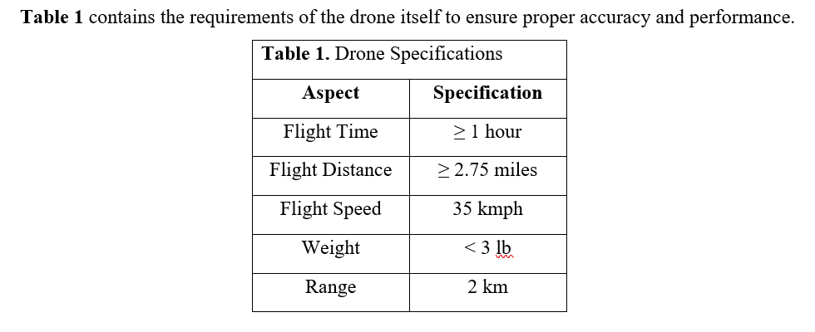

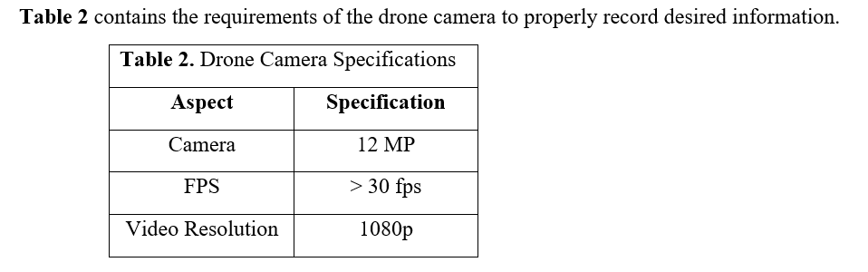

1. **Design Approach and Details**
   1. **Design Concept Ideation, Constraints, Alternatives, and Tradeoffs**

Drone Buddy envisions autonomous safety drones helping people feel and stay safe. The feature it needs to fulfill this goal includes active crime dissuasion and passive crime prevention.

The active crime dissuasion would mean the drone would need to sense danger in the surrounding regions and try to break up the conflict by the use of flashing red and blue lights and a loud speaker. When a crime is taking place, the perpetrator needs or would prefer less light and sound in the area to be able to conduct a stealthy crime. If this does not stop the crime or if it does, the drone along with 2 or 3 other drones will follow all potential perpetrators and victims. This will allow police officers to identify all people involved and to catch the perpetrator and help the victim very quickly.

The passive crime prevention would involve the drones being called upon by a pedestrian. The drone will find and follow the pedestrian until their destination. This would prevent a couple of potential future crimes involving the pedestrian because it is less likely for someone to commit a crime when there is a drone watching their every move.

The autonomous feature of the drone will be a huge roadblock in fully designing the features mentioned because it will require a lot of software computation on a camera feed and audio feed. This would also require this software to control direction, motor speed of the drone, and all decision making for the drone. Another obstacle to deal with is privacy laws regarding videotaping of civilians and drone laws regarding unmanned autonomous drones.

The core design features and their cost can be seen in Appendix B. This cost would include the feasibility of being able to make a completely autonomous drone with the full feature of active crime dissuasion.

* 1. **Preliminary Concept Selection and Justification**

|  |  |  |  |  |  |
| --- | --- | --- | --- | --- | --- |
| **Table 3.** Weighted Decision Matrix for Feature Selection | | | | | |
| Concept | Weighted Criteria | | | | Score |
| Flight Time  (Battery Life) | Development Time | Computability | Functionality/ Convenience |
| 10 | 8 | 4 | 10 |
| Threat Detection | Moderate Effect (4) | Significant Effect (0) | Significant Effect (0) | Significant Effect (10) | 140 |
| App | Negligible Effect (10) | Small-Moderate Effect (7) | Moderate Effect (6) | Significant Effect (10) | 280 |
| Scheduling | Positive Effect (10) | Small Effect (8) | Negligible Effect (10) | Large Effect (8) | 284 |
| Face Detection | Small Effect (8) | Moderate Effect (6) | Moderate Effect (4) | Moderate Effect (7) | 214 |
| Motion Detection | Small Effect (8) | Moderate Effect (7) | Small-Moderate Effect (7) | Significant Effect (10) | 264 |
| Gesture Control | Small Effect (8) | Significant Effect (1) | Moderate-High Effect (2) | Moderate Effect (6) | 156 |
| Pursuit of Assailant | Significant Effect (1) | Significant Effect (2) | Significant Effect (1) | Moderate Effect (6) | 90 |
| Footage  Capture | Moderate-Large Effect (3) | Negligible Effect (10) | Small Effect (8) | Significant Effect (10) | 242 |
| Data Streaming | Moderate-Large Effect (3) | Small Effect (10) | Moderate Effect (4) | Significant Effect (10) | 226 |

Various possible features were scrutinized while formalizing the goals and constraints of the system. A few were discarded for infeasibility of completing development during the given timeline. Those include the inclusion of a threat classification system and gesture control. Another posited feature involving pursuit of an assailant was discarded due to uncertainty surrounding legality and the significant impact such a feature would have on flight time requirements. The table shown above demonstrates the selection criteria used and how each proposed feature performs under those criteria. The features scoring above 200 constitute the set to be implemented. A justification for each criterion follows.

* + 1. **Feature Selection Criteria**

A justification for each criterion used in the selection of the final feature set follows.

* + - 1. **Flight Time**

Achieving sufficient flight time is a keystone design requirement. Consumer drones on the market today have a typical flight time of around 30 minutes [4]. Drone Buddy may need to achieve up to double this to help a commuter reach their destination and return to a charging location. This introduces a major constraint on the hardware used for the drone. Weight increases energy consumption so both the drone chassis and electronics on-board must be chosen to maximize the performance-weight ratio.

* + - 1. **Development Time**

It has been said that when estimating development time of a software project one should triple the best guess and then triple it again just to be safe. For hardware/software systems, that time might as well be doubled on top of the 9x multiplicative factor. With this in mind, the features maximizing the functionality-development time ratio were chosen. The features demonstrating a high ratio in this regard were the app, motion detection and live-streaming capabilities. Looking at the weighted-decision matrix, it is seen that technologically difficult tasks were weeded out by this criterion. Taking those off the drawing board will allow the team to focus on the features central to meeting the specifications set forth in section 3.

* + - 1. **Computability**

Onboard computing power incurs a significant energy cost but is required to service core functionality. This criterion serves to filter out superfluous compute-intensive features that may be more feasible when power efficiency in mobile processors improves. Threat detection, gesture control and assailant pursuit were all excluded due at least partially to this criterion.

* + - 1. **Functionality**

Functionality must be weighed in respect to its development cost but that does not exclude it from being a criterion for feature selection. Gesture control may have been a well-received feature by end-users but it does not constitute a core function of Drone Buddy. As such it was cut to maximize time spent on reaching the primary goal: providing a personal surveillance system to commuters.

* + 1. **Tentative Design Technologies**

At this time a few technologies have been investigated including the OpenCV library which implements image processing algorithms, software development kits such as that included onboard the DJI N3 Flight Controller, and the mobile app development toolkit Flutter. The use of a cellular data service is also a requirement for streaming footage.

* + - 1. **OpenCV**

The OpenCV library implements algorithms for detecting motion in images and the ability to detect faces using Haar cascades. Such technologies will enable the drone to make the most of its camera by focusing on subjects. The library is mature and released under a permissive BSD license making it a primary candidate for use. If a flight controller or single board computer that can make use of the library is chosen, its use is very likely. In fact, the ability of the controller and/or single board computer to support OpenCV will likely be a key selection criterion for that piece of hardware.

* + - 1. **Drone SDKs**

Companies such as DJI have released user-programmable flight controllers that come preloaded with their proprietary flight software. Utilization of such a development kit will free up development resources to focus on the prime objective of Drone Buddy since problems that have already been solved such as motor control and sensor integration are built in. If used, achieving and even maintaining flight will be trivial, allowing the team to focus on a high-level mission control system capable of identifying and following the user. A significant constraint prohibiting use of this technology is budget. The N3 flight controller has a large price tag of $419 [6]. The utility of development kits, thus, must be weighed against their price.

* + - 1. **Flutter**

Flutter has been discussed for use in the app component. It is a cross-platform UI toolkit designed to ease the production of high-quality mobile phone experiences [7]. Its use will enable the team to write a single app and deploy across both major mobile operating systems: Android and iOS.

* + 1. **Undecided Design Aspects**

Little discussion has taken place on one key component: the backend architecture of the system. Database and server-side technologies are very much still up for discussion and such discussion must take place sooner rather than later to ensure the ability of these systems to service user commands via the app and to safely catalog drone footage.

* 1. **Engineering Analyses and Experiment**

**4.3.1** **Initial Metrics Testing**

Once approved, the parts will be ordered and assembled to create the basis of the drone. The drone with any additional battery packs reserved for flying will be tested to make sure that it can fly for at least 1 hour. This will be done by flying it outside for the expected duration.

**4.3.2 Current Tests**

Currently, there have been no tests or analysis due to the global pandemic.

* 1. **Codes and Standards**

The FAA Reauthorization Act of 2018 gives the Federal Aviation Administration power to establish guidelines governing the use of national airspace [2]. Subtitle B lists the statutes regarding the use of unmanned aerial vehicles in public, educational, and recreational capacities.

In section 346, the act explicitly grants the Secretary of Transportation the power to issue a certificate of waiver or certificate of authorization for use of unmanned aircraft systems by government agencies. Several requirements must be met to permit use by a public safety agency including that the aircraft [2]:

1. weigh no more than 4.4 pounds
2. be flown less than 400 feet above ground
3. be operated only during daylight conditions
4. be operated solely within class G airspace at least 5 miles from any location with aviation activities

If the semi-autonomous surveillance drone, Drone Buddy, is to be used in a public safety capacity it must meet these requirements and undergo certification.

During development, the drone will be operated under the statutes governing the use of unmanned aircraft for recreational or educational purposes. The rules for recreational use are set forth in section 349. Those include that the aircraft must [2]:

1. be flown within visual line of sight and
2. no more than 400 feet above ground and
3. be registered and marked which requires passing an aeronautical knowledge and safety test.

The rules for educational use are set forth in section 350 [2].

1. **Schedule, Tasks, and Milestones**

A diagram identifying the critical path of project milestones is given in Appendix C. Investigation of motion tracking algorithms and flight controllers is expected to take up a considerable amount of time over the summer in preparation for the fall semester. The general backend system architecture can be agreed upon and work will begin on the app during this time period as well. Upon the team’s return to campus, part selection will be finalized. Development of the app and system backend is expected to continue while awaiting parts. Upon reception of parts, construction of the drone can begin and the team will seek to implement reliable remote control. After attaining flight, the team will work on implementing motion tracking algorithms and a high-level mission based API. Development of the backend server and app should complete two months prior to the final project demonstration since these components must be stable to ensure that high-level mission control is built on a solid foundation. Work during the last month will focus on ensuring a quality demonstration and preparing the final project deliverables. For a general timeline with estimated dates of completion refer to the Gantt chart in appendix A. Task assignment has not been concluded but will be mostly decided after a few more team meetings discussing the members’ core competencies as well as desires to work on specific parts of the project.

1. **Project Demonstration**

Drone Buddy will be demonstrated on the Georgia Tech campus and surrounding areas. It will be called from central campus to the border of campus by the app and then proceed to keep active surveillance on the commuter until they reach their place of residence. During this demonstration, live surveillance footage will be captured for review. The footage will be annotated to show where motion is detected using an image processing library such as OpenCV and then catalogued in the remote database. The commute will be at least an hour in length and demonstrate that the drone can make a ≥2.75 mile round trip.

1. **Marketing and Cost Analysis**
   1. **Marketing Analysis**

There are no products that fit the exact function of DroneBuddy that are currently on the market. Drone Buddy is aiming at an autonomous drone that is able to accompany someone in order to keep them relatively safe wherever they want to go and to sense nearby danger and track the perpetrator and the victim. These drones would not be controlled by someone 24/7 and will aid police in investigations and prevent future crimes by dissuading perpetrators. Most of the drones currently on the market are used for military purposes. There are companies though, who are building drones for the purpose of safety like DroneSense [5], but these companies are building drones that need someone to control them at all times which would remove any crime preventive nature of the drones. The autonomous nature of Drone Buddies safety drones would be a unique product.

* 1. **Cost Analysis**

The current cost of prototype parts themselves will be about $840. This number is primarily based on the current list of parts required to build an autonomous safety drone. These parts would include normal drone parts such as motors, a drone chassis, batteries, a flight control system, and a suite of sensors. To add to these parts for Drone Buddies specific needs, the list would also include an LTE module, and a relatively powerful onboard computer to run all the machine learning programs necessary for the drone to be autonomous. These parts would be minimum needed parts to create a functioning Drone Buddy but may not be enough for the final product itself. On top of the cost of these parts, our team will spend at least a hundred hours each in the physical construction and the software development of the drone. The engineer’s salary will not be any different from most start-ups but the drone prototype costs may be a bit high due to the drone needing to be autonomous and accompanying hardware and software to go with it (relatively powerful onboard computer).

Present a cost analysis of estimated prototype engineering and construction. Assume that you are being paid a typical engineer’s starting salary. Clearly show estimated hours to be worked on the project for each person on your team (except for class lectures, include all time spent on the course, i.e., meetings, report preparation, etc.). In terms of parts, be reasonably accurate on the “big ticket” (i.e., expensive) items, and provide estimates for small parts. Don’t forget power supplies, cables, and packaging.

Consider just your project and determine a suggested selling price assuming that you sell a certain number of units over a five year time period and that the total development costs are amortized over all of these units. Include estimated materials and labor to fabricate, assemble, and test each unit. Factor in fringe benefits, overhead, and sales expenses. Indicate expected profit (and percent profit) for each unit sold. Give reasonable estimates for parts pricing, not detailed parts costs. You can make appropriate assumptions and educated guesses. Briefly explain how you determined the estimates, and cite references for actual prices you are using.

1. **Current Status**

The current status of the project is at the proposals stage. Due to the Coronavirus, a proper design plan of the drone has not been completed and parts have not been ordered. As for the software part of the drone, the apps necessary for the drone are currently in the user interface development stage and machine learning code necessary to control the drone is in the research stage. Based on Appendix A, the project proposal and the project summary has been completed. Regarding the investigation of the flight controllers, motion sensing tracking algorithms, and part selection, they are close to halfway done, with the research having been completed and now the actual implementation needs to be done. The rest of the tasks as shown in Appendix A have not been started and will be started during Semester 2.

1. **Leadership Roles**

Jerrin Kakkanatt will be the head motor and chassis developer as well as the expo coordinator. Sriharsha Singam will be the head software developer and webmaster. George Germanakos will be the head data collector and analyzer. Zachary Mathews will be the head controller and sensor developer as well as the documentation coordinator.

1. **References**

[1] “Official Store for DJI Drones, Gimbals and Accessories (United States),” DJI store. [Online]. Available: https://store.dji.com/. [Accessed: 11-Apr-2020].

[2] Guthrie and Brett, “Text - H.R.302 - 115th Congress (2017-2018): FAA Reauthorization Act of 2018,” Congress.gov, 05-Oct-2018. [Online]. Available: https://www.congress.gov/bill/115th-congress/house-bill/302/text?q={"search":["FAA+Reauthorization"]}. [Accessed: 16-Apr-2020].

[3] “Georgia Institute of Technology Georgia Institute of Technology Police Department: Atlanta, GA,” Georgia Institute of Technology Police Department | Atlanta, GA. [Online]. Available: http://police.gatech.edu/crime-statistics. [Accessed: 17-Apr-2020].

[4] “DJI - The World Leader in Camera Drones/Quadcopters for Aerial Photography,” *DJI Official*. [Online]. Available: https://www.dji.com/phantom-4-pro-v2/specs. [Accessed: 17-Apr-2020].

[5] “Drone Software Platform for Public Safety,” *DroneSense*. [Online]. Available: https://www.dronesense.com/. [Accessed: 17-Apr-2020].

[6] “N3 Flight Controller - DJI,” DJI Official. [Online]. Available: https://www.dji.com/n3. [Accessed: 17-Apr-2020].

[7] “Beautiful native apps in record time,” *Flutter*. [Online]. Available: https://flutter.dev/. [Accessed: 17-Apr-2020].

**Appendix A - Gantt Chart**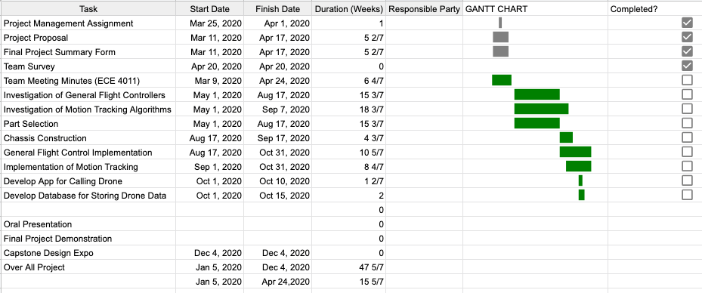

**Appendix B - Quality Function Deployment Diagram**

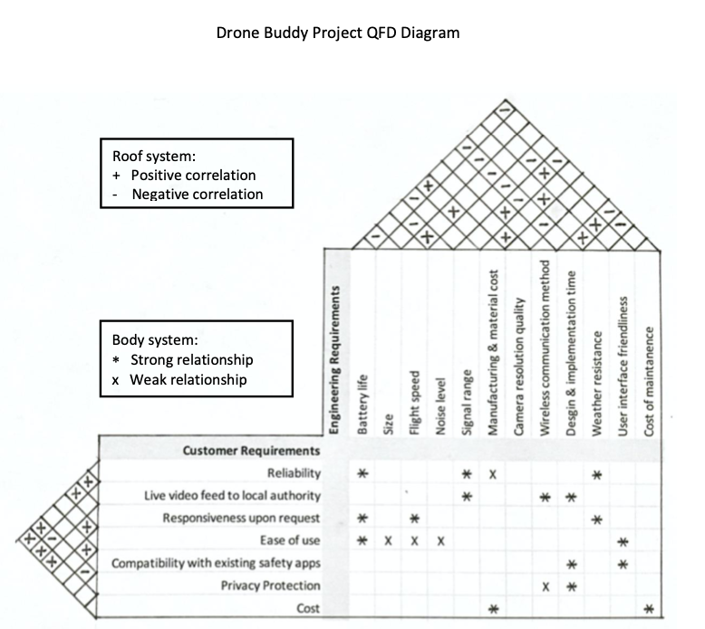

**Appendix C - CPM Diagram**

